SAMPLE LESSON PLAN*

Class: VII
Subject: SCIENCE No. of Periods: 10–12 Unit 2: MATERIALS
Chapter 3: STRUCTURE OF MATTER

PREVIOUS KNOWLEDGE:
The students know that all matter is made up of atoms. They also have the idea that atoms of same kind or different kinds combine together and form molecules, that is, of an element or of a compound, respectively. They also know the properties of different materials.

INTRODUCTION:
The students could be asked the following questions.
- The total number of elements is
- An atom can be observed under a
- The scientist who coined the term atom:
- Water is made up of: and
- The smallest particle of a compound:
- A yellow metal:
- The smallest particle of an element:
- The gas we breathe out:
- Two immiscible liquids: and
- The state of matter with a definite volume but no definite shape:

ANSWERS:
1. | 118 | 2. | microscope
3. | John Dalton | 4. | oxygen, hydrogen
5. | molecule | 6. | gold
7. | atom | 8. | carbon dioxide
9. | water, oil | 10. | liquid
Let start the lesson – Structure of Matter

LEARNING OBJECTIVES:
The students will be able to understand –
- Atoms are so small that they cannot be seen even by the most powerful microscope.
- One water molecule contains two atoms of hydrogen and one atom of oxygen.
- The smallest particle of a compound is a molecule.
- The differences between elements and compounds
- How elements occur in nature?
- Properties of compounds
- How mixtures are formed?
- Differences between a compound and a mixture
Living Science Companion – 7
- Symbols are used to represent elements.
- A compound is represented by a formula.
- Atomicity of elements
- What information does a formula give?
- Concepts of valency
- How to write a formula?
- How to write chemical equations?

* The following lesson plan is meant to be a sample. It is suggestive of the kind of lesson plans that would be useful in planning the teaching programme for the
year. It can be modified to suit the needs of the school.
1

Living Science Companion – 7
METHODOLOGIES:
  - Play-way
  - Discussion
  - Group activity
  - Observation and inference
  - Investigation
  - Experiments
  - Drawing

TEACHING AIDS:
- Coursebook – Living Science 7
- CD provided with the book
- Blackboard and chalk
- Iron, sulphur powder
- China dish
- Magnet
- Bunsen burner
- A chart of Periodic Table

ACTIVITIES:
The following activities could be done:
- To show that mixture of iron and sulphur can be easily separated by using a magnet
- To show that a compound can not be easily separated into its constituent elements

ASSIGNEMENTS:
- Class Assignment or Classwork:
  - New words like atomicity, valency to be written in notebook
  - Q. A to be done in book
  - Q. B, C to be done in notebook after discussion in Class
  - Q. D – answers to be discussed in Class
- Home Assignment or Homework:
  - Reading the lesson properly
  - Q. D – answers to be written in notebook at home
  - Figure 3.1 and Figure 3.2 to be drawn in notebook

2

NUTRITION IN PLANTS
- 8 Oral Questions
  - The new organism will be classified as an autotroph. This is because only green plants or autotrophs can make food from simple non-living substances, that are carbon dioxide and water.
  - The absence of oxygen will not affect photosynthesis. In photosynthesis, carbon dioxide and water combine in the presence of chlorophyll and sunlight to form glucose (food) and oxygen. So, oxygen is released in the process and hence not needed in photosynthesis.
  - Yes, the intensity of light will affect the rate of photosynthesis.

11 Oral Questions
  - No, the statement is not true. A tiger does not eat plants but it does depend on plants for food. A tiger eat herbivores which in turn eat plants. Thus, a tiger indirectly depends on food prepared by plants.
  - All plants are not autotrophic. Non-green plants cannot prepare their own food as they do not have chlorophyll.
  - No, I do not agree with this statement that after sometime the nutrient level of the soil in a forest becomes so low that growth of trees will suffer. Because, in a forest the nutrients in the soil get naturally replenished by decaying of dead plants and animals.
  - No, the plants cannot absorb nitrogen from the atmosphere. They get it in a soluble form from the soil.
P. 12 Exercises
A. 1. c 2. b 3. d 4. a
5. c 6. d 7. a 8. b
- 1. heterotrophs 2. chloroplasts
3. light 4. Rhizobium
5. plant parasite 6. symbiosis
7. saprotrophs, 8. blue-black for example, fungi
9. sun or solar energy 10. false
11. true 12. guard cells
- 1. The process of taking in food by an organism and its utilization by the body is called nutrition.
- Stomata are tiny pores through which leaves take in carbon dioxide from the air. Stomata are found on the underside of the leaves.
- Carbon dioxide + Water
Sunlight Glucose + Oxygen
æææææÆ
Chlorophyll
- Water, carbon dioxide, chlorophyll and sunlight are essential for photosynthesis to take place. In photosynthesis, carbon dioxide and water combine in the presence of chlorophyll and sunlight to form glucose and oxygen.
- The cells of an insectivorous plant secrete digestive juices to absorb nutrients from an insect trapped by it.
- Nitrogenous fertilizer is not added in soil in which leguminous plants are grown. This is so because farmers know that leguminous plants like gram, peas contain Rhizobium bacteria in their roots which convert atmospheric nitrogen into a soluble form that the plants can absorb.
- Saprophyte like a mushroom secretes digestive juice on the dead and decaying matter. This juice converts the solid matter into a liquid. The saprophyte then absorbs the nutrients from this liquid.

- 1. Autotrophs: The organisms which can make their food from simple non-living substances are called autotrophs. Examples: green plants and Sulphur bacteria.
Heterotrophs: The organisms which can not make their own food, and depend on green plants for their nutrition directly or indirectly are called heterotrophs. Examples: animals and non-green plants.

2. To test a leaf for starch: Pluck a leaf from a plant that has been exposed to sunlight. Boil it for about five minutes in water to soften it. Place it in a test tube containing alcohol and indirectly boil it in a water-filled beaker or water-trough. The alcohol will dissolve the chlorophyll and the leaf will lose its green colour. Wash the leaf in warm water to remove the alcohol. Now spread the leaf out flat on a tile and pour iodine solution on it. Remove the leaf from the iodine and wash it with water. Hold it up against the light. You will observe that parts of the leaf become blue-black which proves the presence of starch in it. Precaution: The water in the beaker should not be allowed to boil.
3.Plants get nitrogen to synthesize proteins in two ways:
  - Soil contains certain bacteria called Rhizobium that can convert atmospheric nitrogen into water-soluble compounds. Plants absorb these compounds along with water to get nitrogen.
Living Science Companion – 7
  - Farmers add fertilizers rich in nitrogen to the soil. These are absorbed by plants.
4.All animals whether herbivores, carnivores or omnivores can not prepare their own food. They are known as heterotrophs. They depend directly or indirectly on green plants for their nutrition. Herbivores depend directly on plants for their food. Carnivores depend on other animals, which in turn depend on
plants. Omnivores depend both on plants and herbivores for their food.
3

- a. Parasitic nutrition: The mode of nutrition
in which organisms live in or on other living organisms (hosts) to derive their food from them is known as parasitic nutrition.
Example: dodder
- Symbiosis: The mode of nutrition where two different organisms work together for their mutual benefit is called symbiosis. Example: Rhizobium and leguminous plants. Rhizobium converts atmospheric nitrogen to soluble nitrogen for the host plant and the host plant in turn supplies food and shelter to Rhizobium.
- Saprotrophic nutrition: The mode of nutrition in which organisms live on dead and decaying matter (plants and animals) to derive their food from them is known as saprotrophic nutrition. Example: mushroom
- Plants absorb nutrients from the soil. Therefore, the amount of nutrients in the soil goes on decreasing. In a farm these nutrients have to be added to the soil in the form of manure and fertilizers. They contain plant nutrients such as nitrogen, potassium and phosphorus.
- Parasites: Some non-green plants live in or on other living organisms to derive their food from them. These plants are known as parasites. Example: dodder.
Partial parasites: Some parasitic plants growing on other trees have green leaves and can synthesize their food. They take water and minerals from the host plants. Such plants are known as partial parasites. Example: mistletoe plant grows on mango tree

HOTS Questions
- Green plants are autotrophs because they synthesize their own food from simple non- living raw materials – carbon dioxide and water. We cannot be called autotrophs because the food we make in the kitchen comes directly or indirectly from the food made by plants.
- Animals cannot make food from carbon dioxide, water and sunlight like plants do because photosynthesis requires chlorophyll also which animals do not have.
Living Science Companion – 7
- Pitcher plant and Venus flytrap plant grow in soil that is not so rich in nutrients. They need to feed on insects to use the nutrition obtained from insects to supplement the food they prepare by photosynthesis.
- Plants do not need a digestive system because they do not consume complex food like us. They prepare their own simple food (glucose) which can be directly used by the plant without the need to digest it first.
4

Be a Scientist
- By measuring the volume of oxygen given off in a certain time.
- By bubbling carbon dioxide through the water (carbon dioxide is soluble in water to some extent). A more accurate method will be to add sodium hydrogen carbonate to water, about 0.1 g at a time.
- The amount of light falling on the plant should also be kept constant.
- As the carbon dioxide supply increases, the rate of photosynthesis also increases initially.
- The rate of photosynthesis ultimately levels off because of some other limiting factor (for example, the amount of light available)

2. NUTRITION IN ANIMALS
- 16 Oral Questions
  - Food needs to be digested because the food we eat is not in a form that can instantly provide us with nutrients. Food has to be broken down to a simple, soluble form which the body cells can absorb.
  - No, digestion of food does not occur inside the body in all animals. For example, the digestion of a spider’s food takes place outside the spider’s body.
  - Mosquito, housefly

20 Oral Questions
  - Stomach, small intestine
  - No, absorption of the digested food occurs in the small intestine.
  - No, I do not agree. Some digestive juices are also secreted by the liver and pancreas.
The liver secretes bile juice and the pancreas secretes the pancreatic juice.
  - The food after it is digested, and absorbed by the blood is transported to different parts of the body. This is used to provide energy and materials for growth and repair of body tissue.
P. 21 Exercises
A. 1. d 2. d 3. b 4. d
5. c 6. b 7. b 8. d
9. a 10. b
- 1. soluble 2. assimilation 3. food vacuole
4. false 5. false 6. stomach
7. enamel 8. large intestine
9. cud 10. false
- 1. A frog uses its long sticky tongue to catch its prey.
- A spider injects digestive juices into the body of the insect caught in a sticky web formed by the spider. This digests the body parts of the insect and the spider then sucks up the digested food.
- The organs that make up the human alimentary canal are
  - mouth, (ii) food pipe or oesophagus,

(iii) stomach, (iv) small intestine,
(v) large intestine, (vi) rectum, and
(vii) anus.
- Differences between milk teeth and permanent teeth are as follows.
Milk teeth: The first set of teeth, 20 in number,
grown in a child are milk teeth.
Permanent teeth: Milk teeth fall off by the age of ten and are replaced by larger permanent teeth, 32 in number.
- Saliva is a digestive juice. It is produced by three pairs of salivary glands in our mouth.
- Taste buds detect all tastes – sweet, salty, sour and bitter.
- Food stays in the stomach from a few minutes to a few hours depending on the type of food eaten.
- The acid in the stomach kills bacteria present in the food and also helps in digestion of proteins.
- 1. The various processes involved in nutrition in animals are as follows:
  - Ingestion: It is the process of taking in food through the mouth and eating it.
  - Digestion: It is the process of breaking down of food into a simple, soluble form with the help of digestive juices in the body.
  - Absorption: It is the process by which the food in the soluble form passes into the body fluids such as blood.
  - Assimilation: It is the process of using the absorbed food to produce energy and for growth.
  - Egestion: It is the process of elimination of undigested solid parts of the food.
- a. Amoeba engulfs tiny particles of food by throwing its false feet, known as
pseudopodia around it. The pseudopodia join together to form a small cavity known as a food vacuole.
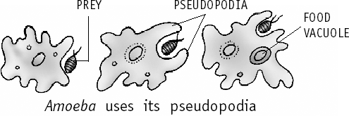
b. Hydra has a number of tentacles around its mouth, which are used for ingestion of food. The tentacles entangle small aquatic animals and kill them with their stinging cells. They then push them into the mouth.
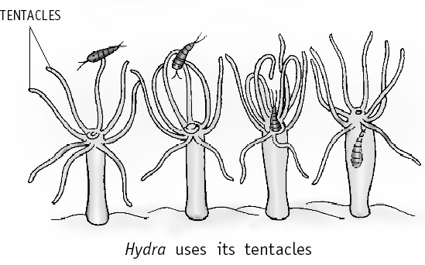
- The four types of teeth in our mouth and their functions are:
  - Incisors (or biting teeth): are used for biting and cutting.
  - Canines (or tearing teeth): are used for tearing pieces of food such as meat.
  - Premolars (or crushing teeth): are used for crushing food like nuts.
  - Molars (or grinding teeth): are used for grinding and chewing food.
- The muscular movement of contraction and expansion to push food down in our oesophagus to our stomach in a wave-like action is called peristalsis.

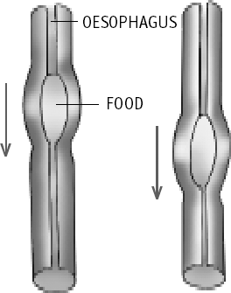
- a. The function of saliva: (i) It helps to break down starch of the food into sugars that are easier to digest. (ii) It also makes food softer and easier to swallow by making it wet and slippery.
- The function of bile juice: The bile breaks up fats into tiny droplets that can be digested and absorbed more easily.
- The function of pancreatic juice: Pancreatic juice changes starch into simple sugars in small intestine and proteins into simpler compounds called amino acids.
- a. Food in stomach: Stomach secretes mucous, hydrochloric acid and digestive juices. The acid kills bacteria that enter alongwith food and also helps in digestion of proteins. The digestive juices break down proteins to simpler substances. Thus, food gets partly digested in the stomach.
- Food in small intestine: The muscles in the small intestine mix food with more digestive juices from its wall, some from liver (bile juice) and some from pancreas (pancreatic juice). Bile and digestive juice
Living Science Companion – 7
from intestinal wall together act on fats and break it into simplest form as fatty acids and glycerol. Pancreatic juice changes starch into simple sugars and proteins into simpler compounds called amino acids. Thus, digestion completes in small intestine and then it is absorbed by the intestinal wall.
- The digested food is absorbed into thousands
5
of small finger-like projections in the inner walls

of small intestine. These projections called villi increase the surface area of absorption of digested food. Each villus has a network of fine blood capillaries close to the surface. So the food absorbed on the surface of the villus passes into the blood in the capillaries.
- Process of digestion in ruminants: Ruminants have stomachs consisting of four chambers. Food that is swallowed goes into the first chamber called the rumen. Here it is partially digested and is called cud. Then it goes to the second chamber from where it is returned to the mouth for thorough chewing. This process is called rumination. After chewing, the food is swallowed for a second time and then digested further in the remaining chambers. Absorption of the nutrients is done in small intestine.

HOTS Questions
- Sugar is a simpler food than proteins and carbohydrates (present in beans). Therefore sugar will be digested faster than beans.
- Digestion needs the help of the respiratory and circulatory systems to get energy from food. The circulatory system takes the digested food to the cells of the body. The respiratory system provides the oxygen required to convert the food into energy.
- If we eat food while hanging upside down it will still go through the alimentary canal because of peristaltic movement of the oesophagus and the alimentary canal.

Be a Scientist
Animals in their natural habitat have to constantly move around and put in a lot of effort to find food. They do not have a sedentary lifestyle like many overweight
humans. However, pets do tend to become overweight as they get food easily and may not get enough exercise.

3. STRUCTURE OF MATTER
- 28 Oral Questions
  - Smallest particle of an element is an atom of that element.
Living Science Companion – 7
Smallest particle of a compound is a molecule of that compound.
  - No, as atoms of some elements may not exist independently.
  - No, because most elements have a tendency to combine with each other to form compounds.
  - No, it is incorrect.
  - Yes, it is correct.

33 Oral Questions
  - Symbol – O, formula – O2
  - Valency. No, this is not a modern definition.
6
3. 3, 6
4. No, the number of hydrogen atoms is not equal in both sides.
P. 34 Exercises
A. 1. c 2. d 3. a
4. b 5. c 6. c
7. b 8. d 9. b
- 1. atom 2. molecule 3. oxygen
4. hydrogen 5. 3 6. a mixture
- a mixture
- an atom, a. Co, b. Cu, c. Cl, d. C
- a. H2SO4, b. Ca(OH)2, c. C6H12O6, d. NaCl
- 2 11. true 12. False

- When two elements mix together under favourable conditions, they combine chemically in a fixed ratio to form a compound.

- The properties of different compounds are so different from each other due to following reasons:
  - Their constituent elements are different.
  - Sometimes their constituent elements are same but ratios are different. Example, H2O (Water) and H2O2 (Hydrogen peroxide)
- Many elements have a great tendency to
combine with each other to form compounds. These elements cannot exist independently, therefore, not found in the free state in nature.

- On heating a mixture of iron and sulphur, a black substance called iron sulphide is formed. The ratio of iron and sulphur in iron sulphide is always 7 : 4.
Fe + S FeS
- A formula represents:
  - the types of elements present in the compound.
  - the number of atoms of each element present in the compound.
  - the molecule of the compound.
- The valencies of other elements or groups is the number of hydrogen atoms which can
combine with or be displaced by one atom of that element or group.
- 1. The differences between an element and a compound are as follows.
Element
  - A substance that cannot be decomposed into simpler substances by chemical means and is made up of only one kind of atoms
is called an element. Examples: hydrogen, oxygen
  - An element cannot be broken further.
  - There are 118 elements on the earth.
Compound
- A substance formed by the chemical combination of two or more elements in fixed proportions is called a compound.
Example: water
- A compound can be broken into its constituent elements by chemical reaction.

- There are innumerable compounds around us.
- An atom is the smallest particle of an element that can take part in a chemical reaction. It may or may not exist independently.
A molecule is the smallest particle of an element that can normally exist independently. Yes, a molecule of an element can be the same as its atom. That means its atom exists independently. This element is known as monoatomic element. Example: He (Helium).
- a. sodium oxide Na1O2 Na2O
  - magnesium nitrate Mg2(NO3)1 Mg(NO3)2
  - magnesium sulphate Mg2(SO4)2 MgSO4
  - aluminium chloride Al3Cl1 AlCl3
- A chemical equation shows the result of a
chemical reaction in which the reactants and the products are represented by symbols or formulae.
Example: Fe + S FeS
iron sulphur iron sulphide
It is necessary to balance an equation because the number of each element should be the same on both sides of the equation.
Example: H2O H2 + O2 [Not balanced] 2H2O 2H2 + O2 [Balanced]
- a. Mg + H2SO4 MgSO4 + H2
It is a balanced equation.
- CaCO3 + HCl CaCl2 + H2O + CO2
[Not balanced]
CaCO3 + 2HCl CaCl2 + H2O + CO2
[Balanced]
- CaO + H2O Ca(OH)2 It is a balanced equation.
- Ag + HNO3 AgNO3 + H2O + NO2 [Not balanced]
Ag + 2HNO3 AgNO3 + H2O + NO2
[Balanced]
- The formula of a compound can be written if the symbols of its elements or radicals and their valencies are known.
For example, calcium chloride
The elements in calcium chloride are calcium and chlorine. The valency of calcium is 2 and the valency of chlorine is 1. So we write them as Ca2Cl1. There is no common factor in the valencies 2 and 1. Interchanging the valencies and writing them as subscripts, we get the formula of calcium chloride as CaCl2.

HOTS Questions
- Its formula is X only if it is a monoatomic element, e.g. helium He; calcium Ca, carbon C. In case of elements that are not monoatomic, the formula is different; e.g. nitrogen N2, Phosphorus P4.
- A broken atom of gold will not have the same properties as an atom of gold.
- In spite of being the second most abundant element in the universe, there are no known compounds of helium because it is an unreactive element with 0 valency.

Be a Scientist
CH4 + 2O2 CO2 + 2H2O

ANIMAL FIBRES
- 40 Oral Questions
  - cotton – P, cashmere – A, flax – P, jute – P,
wool – A, silk – A
(P for plant fibre and A for animal fibre)
  - Angora fibre comes from Angora rabbit.
  - Air spaces between the wool fibres trap air. Air is a bad conductor of heat. So this shields the body from cold and keeps it warm.
  - Thickness, length, shine, strength and colour decide the quality of the wool.
P. 42 Oral Questions
1. pupa, 5500
- The thread obtained by twisting the filaments of
cocoons is called raw silk.
- boiling water, filaments, filaments, raw
- Because they inhale the vapours arising from cocoons undergoing various processes like steaming, cooking and reeling.
P. 43 Exercises
A. 1. c 2. c 3. a
4. c 5. c
- 1. Name of the source
  - silk silkworm
  - wool sheep
  - angora Angora rabbit
2. proteins 3. cellulose 4. shearing
5. Sericulture 6. true
- 1. The fibres that are obtained from natural sources like plants and animals are called natural fibres.
- Five animals from which wool is obtained are
  - sheep — normal wool
  - cashmere goat — cashmere
  - Angora rabbit — angora
  - Angora goat — mohair
  - yak — yak wool
Living Science Companion – 7
- cotton, flax, jute
- Natural lustrous appearance of silk makes it so attractive.
- The basis to decide the qualities of wool obtained from sheep are thickness, length, shine, strength and colour of the fibre.
- The two types of fibres obtained from the fleece of a sheep are the coarse beard hair, and the fine and soft under-hair that grows close to the skin. The under-hair is used to make wool.
7
- 1. We wear clothes to protect us against heat,

cold and rain mainly. Thus, it has to be suited to the weather. In summer, we wear loose, light-coloured cotton clothes. Cotton clothes allow air to circulate freely and so the heat
of the body escapes. Light coloured cotton clothes reflect heat and keep the body cool. They absorb sweat and also prevent skin irritation. In winter, we wear thick, dark-coloured clothes made of wool, fur, or leather to prevent our body heat from escaping. During the rainy season, we use raincoats and umbrellas.
- Differences between animal and plant fibres as
follows:
Animal fibres:
  - Animal fibres are made up of proteins.
  - Examples are wool and silk.
Plant fibres:
- The base of plant fibres is cellulose.
- Examples are cotton, the most widely used
of all textile fibres, and jute.
- Air spaces between the wool fibres trap air. Since air is a poor conductor of heat, this shields the body from cold and keeps it warm. Again wool is a bad conductor of heat. This way woollen clothes help in keeping our body warm.
4.

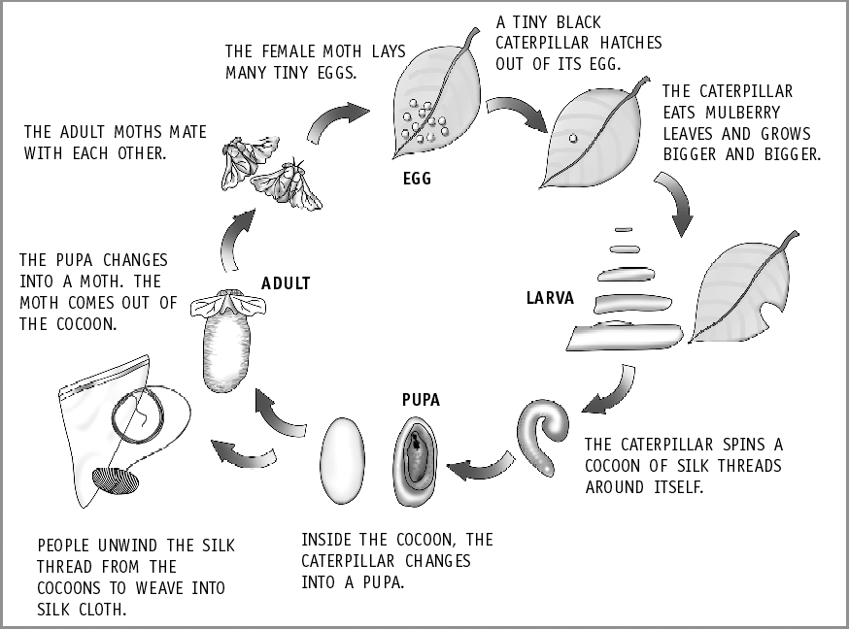
- a. Incubation: The silk moth eggs are warmed to a temperature suitable for hatching. This is known as incubation.
Living Science Companion – 7
  - Rearing: After hatching, the silkworms are fed on mulberry leaves for six weeks, and the worms eat almost continuously and increase in size.
  - Spinning: Branches of trees or shrubs are placed in their rearing houses. The worms climb these branches and make their cocoons out of one continuous thread.
  - Reeling: The cocoons are first boiled or treated in ovens, killing the insects by heat. The silk fibre is then obtained from the cocoons by a
8
delicate process known as reeling.
- Workers employed in the sericulture industry are adversely affected by a number of diseases.
  - Respiratory diseases: Inhalation of vapours arising from cocoons undergoing steaming, cooking and reeling produces breathing problems, asthma and other bronchial ailments.
  - Scabies and other skin infections: As a result of constant dipping of cocoons
in boiling water, the skin of the workers becomes raw and blistered, resulting in peeling of the skin of hands and feet.

HOTS Questions
- Shearing of sheep is not done during the cold season because nothing will be left on their bare bodies to protect them from severe cold. They may even die without wool in winter.
- Shearing does not hurt a sheep. It is just like getting a haircut.
- Animal activists are against the present process of getting silk from the cocoon because in this process the pupa are killed in a cruel way by boiling them in water.
- Wool traps the most air. Because of this, it is the best insulator and hence very good for winter clothing.

HEAT AND ITS EFFECTS
- 50 Oral Questions
  - Heat is a form of energy. It is known as thermal energy.
  - When we heat a substance, three of the changes that can be observed are: increase in temperature, change of state, occurrence of chemical change
  - No, I do not agree. The expansion will be different for different solids for the same increase in temperature. Because, the molecular arrangement and the average distance between the molecules in different solids are different.
  - solids, liquids, gases

53 Oral Questions
  - We use the measure of temperature to compare the hotness or coldness of a body.
  - The Celsius scale is more convenient to use. Because it correlates well with the more convenient decimal system.
  - The Kelvin temperature scale is used for
scientific work.
  - The property of expansion of matter on heating is used to measure temperature. For this, matter in liquid state is more commonly used.
  - A thermometer is used to measure temperature. The special name given to the

instrument used to measure body temperature is clinical thermometer.
P. 54 Exercises
A. 1. d 2. b 3. d 4. c
5. b 6. b 7. b 8. a
- 1. energy 2. Kelvin
3. ball 4. V1
5. gases 6. false

On heating a gas, the vibrations of its molecules increase. Since the molecules are not bound to each other at all, the average distance between the molecules increases considerably. Hence, the expansion will be more in case of gases than in liquids or solids.
- Fill a flask up to the brim with water. Take a
rubber cork with a hole in it and insert a narrow

7. left a little loose 8. F =
Á
- false
Ê 9 × Cˆ˜ + 32

tube into the hole. Fix the cork firmly in the mouth of the flask. The liquid will rise a little in

- Upper fixed point of Celsius scale is 100 °C and that of Fahrenheit scale is 212 °F.
¯
Ë 5
- clinical
- 1. Four effects that heat produces are:
  - increase in temperature
  - expansion
  - change of state
  - chemical changes
- A bimetallic strip consists of two metal strips, one of iron and the other of brass.
- In a steel bridge, one end is kept on rollers having enough space for expansion in summer.
- Temperature and hotness of a body are related in a way that hotter the body is, the higher is its temperature.
- Upper fixed point is the temperature (on a
scale) at which pure water boils at sea level.
- A clinical thermometer has a kink on its stem because when taken out of one’s mouth, the liquid in the bulb contracts and the mercury column breaks at the kink. Thus the level of mercury in the stem remains the same and we get a correct reading.
- 1. When we heat a substance, the movements of its molecules increase. This increases the average distance between the molecules. Therefore, the space occupied by the molecules, i.e. the volume of the substance increases. Thus we say that heat causes expansion.
2. In steel bridges, one end is made to rest on rollers with enough space provided for expansion during summers. This is one
example where expansion on heating is put to good use.

the tube. Note the level of the liquid. Now, heat the liquid. You will notice that the level of the liquid in the tube goes down a little and then starts rising. It goes down initially as the flask gets heated first and expands. When the heat reaches the liquid, it expands, and its level in the tube goes up.

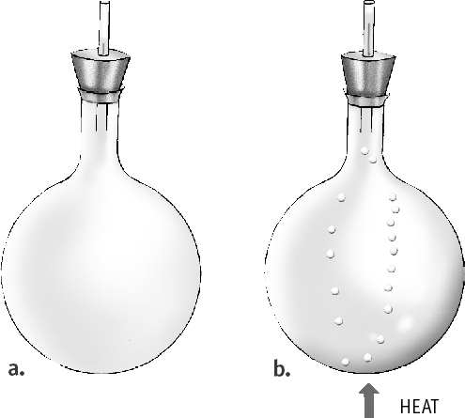
- Expansion on heating can cause some problems as explained below.
  - In summers, electric cables between two poles expand and sag. In winters, they contract and become taut. If cables are laid in summers, they must be left a little loose to allow for contraction during winters. If this is not done, they may break on contraction in winters.
  - The railway tracks over which trains run are made of iron. During summers, the iron expands. To allow this expansion, space has to be left between two sections of the rail tracks. If this is not done, expansion of the tracks can cause them to bend. This can cause serious accidents.
Living Science Companion – 7
- Convert 25 °C to °F

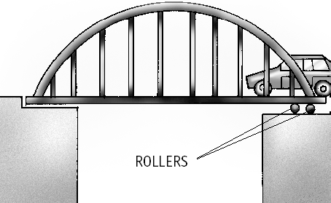
Solution: F = ÊÁ 9
Ë 5
× Cˆ˜
+ 32

= 9 × 25 5 + 32
¯
5

Convert 86 °F to °C
= 45 + 32
= 77 °F
9

Solution: C = 5 9
= 5
9
= 5
9

(F – 32)

× (86 – 32)
× 54 6 = 30 °C
whereas boiling water’s temperature is
100 °C. If inserted in boiling water, a clinical thermometer will crack as the mercury will expand beyond the stem.
4. A laboratory thermometer is not used to measure body temperature because its mercury level falls as soon as it is taken out of the mouth and

7. Let us take C = x, thus F = 2x
According to the formula, we get
the reading cannot be correctly taken.
5. The thick-walled glass tumbler is more likely to

F =

or 2x =
9x
Ê 9 × Cˆ˜
Ê 9 x ˆ
Á
Á
¯
¯
Ë 5
× ˜
Ë 5
+ 32

+ 32
crack. There is greater temperature difference between the inner and the outer surfaces of a thick-walled tumbler when hot water is poured into it, as compared to a thin-walled tumbler. This causes greater difference in expansion

or 2x =
+ 32
5
between the inner and the outer surfaces. The
resulting strain cracks the tumbler.

or 10x – 9x = 32 × 5
∴ x = 160 °C
∴ 2x = 2 × 160 = 320 °F
Thus, at 320 °F, the reading on the Fahrenheit scale will be double of the reading on the Celsius scale, i.e. 160 °C.
- While measuring temperature with a laboratory thermometer, the following precautions should be observed:
  - The thermometer should be washed before and after use.
  - A thermometer is delicate and should be handled with care to avoid breakage.
  - It should not be held by the bulb while reading the temperature.
  - It should be kept upright and not tilted.
  - The bulb should be completely surrounded by the substance whose temperature is being measured and the bulb should not touch the sides of the container.
  - While reading the thermometer, the level of mercury should be at the same level as the eye.
The extra precautions to be taken while measuring body temperature with a clinical thermometer are:
- Wash the clinical thermometer before use, preferably with an antiseptic solution.
- Hold it with the stem and give it a few jerks, to ensure that the level of mercury falls to its normal level.
Living Science Companion – 7

HOTS Questions
- In a cold place where the night temperature drops to –50 °C, we must carry alcohol thermometer because alcohol freezes at
–117 °C whereas mercury freezes at – 39 °C.
- 1° rise in the Celsius scale is greater than 1°
rise in the Fahrenheit scale.
- A clinical thermometer cannot be used to measure the temperature of boiling water because it has a range of 35 °C to 42 °C
10

Be a Scientist
- Gaps have to be longer since the greater the length of the rails, the greater will be the expansion in length.
- Join all rails together and give a long expansion space at the end.

6. FLOW OF HEAT
- 60 Oral Questions
  - The difference in the temperatures of the two objects in contact determines the direction of flow of heat.
  - conduction
  - iron, silver are conductors; wood, plastic are insulators
  - bad conductors of heat

62 Oral Questions
  - by the heated molecules themselves
  - Because, the positions of the molecules in solid
are fixed.
  - sea breeze

64 Oral Questions
  - radiation
  - radiation
  - dark-coloured object
  - dark-coloured object
  - thermos flask
P. 66 Exercises
A. 1. a 2. b 3. b
4. d 5. b 6. d
7. a 8. c 9. a
- 1. conduction 2. good conductors
3. true 4. convection
5. mercury 6. convection
7. radiation 8. false
9. reflected, transmitted
- 1. The conditions necessary for transfer of heat from one body to another by conduction are:
  - The two objects must be in contact;
  - Their temperatures should not be the same.

- Substances which allow heat to be conducted through them easily are called good conductors of heat. For example, iron and silver are good conductors of heat.
Substances which do not allow heat to be conducted through them easily are called bad conductors of heat. For example, wood and plastic are bad conductors of heat.
- Wool fibres have pores in them which are filled up with air which is a bad conductor of
heat. Thus, wool (an insulator) and air together prevent the heat from our bodies from escaping out. So, woollen clothes keep us warmer in winters than cotton clothes.
- Ventilators in houses are provided high up on the walls because the air we breathe out is warmer and lighter, and rises up. Warm air
escapes from the ventilators. It is replaced by cool and heavier fresh air coming in from doors and windows below due to the convection.
- The heat from the sun reaches us through millions of miles of empty space by radiation only. This heat travels with the same speed as light.
- The polished curved surface at the back of the heating rod in a room heater reflects almost all the radiant heat from the heating element that falls on it. This makes the room heater more effective.
- 1. Take an iron rod. Fix thumb-tacks along the length of the rod, using wax. Heat one end of the rod. As the rod gets heated, the wax melts and the thumb-tacks fall off. We will find that the thumb-tack nearest to the end being heated falls off first. The farthest thumb-tack falls off last. This shows that heat is travelling along
the length of the rod from the hot end to the cold end.
- Use of good conductors of heat: We use good conductors of heat whenever we want heat to be transferred fast, e.g. cooking utensils are made of metals such as brass or aluminium which are good conductors of heat.
Use of bad conductors of heat: We use bad conductors of heat whenever we do not want heat to be transferred quickly, e.g. handles of cooking utensils are made of bad conductors of heat such as wood or plastic.
- Take a closed rectangular glass box. With two holes in its top, fit two wide glass tubes to form chimneys. Put a small lighted candle below one of the chimneys. Hold a smouldering piece of paper at the top of the other chimney. We will see smoke entering the box through that chimney. It then gets heated up by the candle and comes out of the other chimney. As the
air above the candle gets heated, it becomes
lighter and rises up. It is replaced by fresh air sucked in from the other chimney. The
smoke is sucked in along with air and sets the convection current shown in the box.
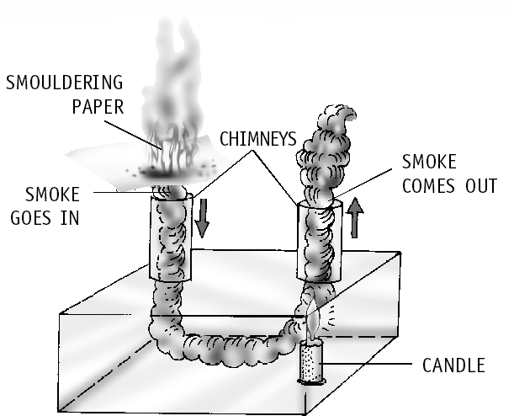
- Sea breeze: During the day, land heats up more than water. The air over the land
becomes hotter and lighter and rises up. The air from the sea, which is cooler and heavier, rushes to take the place created by the hot rising air. Therefore, a sea breeze blows during the day.
Land breeze: During the night, land loses heat faster than water and becomes cooler. The air over the sea is now warmer. It rises up and the cooler air over the land rushes to take its place. Thus, we observe a land breeze at night.

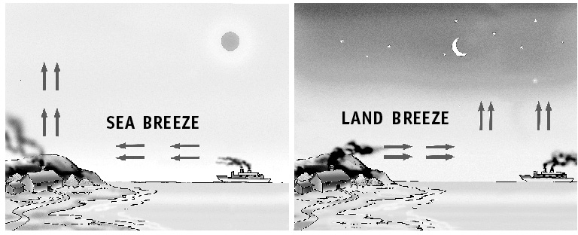
- Black objects absorb more heat than white or polished ones. Two daily uses of this are:
  - The outer base of a cooking utensil is painted black so that it absorbs more heat so that cooking can be done in less time.
  - Dark-coloured clothes are suitable in winters as they absorb more heat.
- Black objects radiate more heat than white objects. Two everyday uses of this principle are:
Living Science Companion – 7
  - The back of refrigerators are coloured dull black to radiate heat more effectively in order to cool down the refrigerator pipes.
  - Electric hot plates are also coloured dull black to radiate maximum heat.
- The vacuum between the two glass walls of the
thermos flask considerably reduces the flow
of heat by conduction and convection. This is because both conduction and convection need molecules of a medium for transfer of heat. The silvered surfaces reflect the heat back, thus, reducing radiation.
11

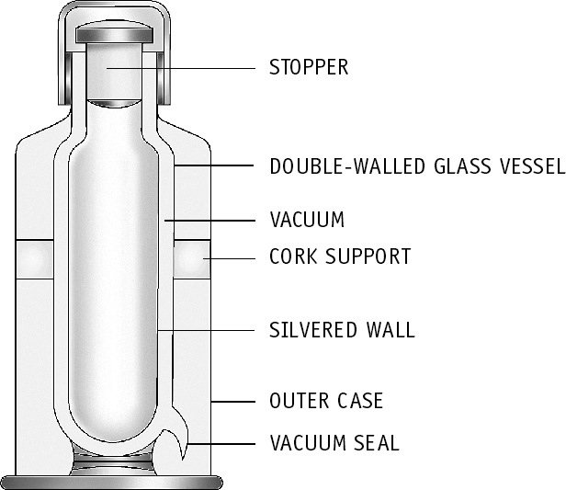

- The water in the test tube which is heated from below will heat up faster. Water is a bad conductor of heat. So, in case of the test tube heated from top, it will not easily conduct heat from the top to the bottom.
But, water transfers heat through convection. In case of the test tube heated from the bottom, water molecules getting heated become lighter and rise up. These molecules pass on their heat energy to the surrounding cold molecules and this heat is carried to all parts of water.

HOTS Questions
- In water, heat travels down by conduction and up by convection. Water is a bad conductor
of heat, therefore, heat travels down slowly in it. Since the molecules of water are free to move around in the water, transfer of heat by
convection is faster. That is why heat travels up faster in it.
- In places with hot climate, it is advised that the outer walls of houses be painted white because white colour absorbs less radiant heat than any dark colour.
- Heat will not be transferred from one object to another because heat is only transferred from hot object to cold object and not from equally hot bigger object to smaller object.
- In a room, it is best to place a room heater on the floor because hot air is lighter and rises up. But an air-conditioner is best placed near the ceiling because cold air is heavier, thus comes down.
Living Science Companion – 7
- Cloudy nights are warmer than clear nights because heat radiated from earth at night cannot escape in the atmosphere due to clouds.
- Feathers of a bird trap air which acts as insulator, protecting its body from cold.

Be a Scientist
In an inverted fur coat, the fur is inside, between the body and the outer lining. The air trapped in the fur is warmer as it is more effectively insulated from the cold air outside.
12

ACIDS, BASES AND SALTS
- 74 Oral Questions
  - acetic acid and citric acid
  - Acids are corrosive in nature. Strong acids can corrode even metals like iron and aluminium. Hence, acids are not stored in metal containers.
  - litmus paper and methyl orange; acid–base indicators
  - neutralization reaction, salt
  - Organic acids are naturally occurring acids that are present in animal and plant products. They are normally weak acids. Hydrochloric acid, sulphuric acid and nitric acid are known as mineral acids. They are normally strong acids.

75 Oral Questions
  - Bases which are soluble in water are called alkalis. But some bases are not soluble in water, so they are not alkalis. That is why all alkalis are bases but all bases are not alkalis.
  - I will not recommend that quicklime or slaked lime be added to the soil to neutralize the acid present in it.
  - sodium hydroxide (NaOH)
  - hydrochloric acid (HCl), magnesium hydroxide is used as an antacid to neutralize the excess acid in the stomach

77 Oral Questions
  - If we replace hydrogen of an acid with a metal, a salt is formed.
  - a salt and water
  - a. nitric acid b. carbonic acid c. hydrochloric acid d. sulphuric acid
  - a salt; sodium bicarbonate (NaHCO3)
P. 78 Exercises
A. 1. d 2. a 3. c
4. d 5. c 6. a
7. d 8. d 9. b
- 1. sodium chloride 2. an acid
3. red 4. false
5. nitric acid 6. lactic
7. carbon dioxide 8. neutralization
9. sulphuric acid 10. alkali
- ammonium hydroxide
- a base 13. pale yellow
14. caustic soda 15. magnesium hydroxide
16. true 17. blue
- 1. The substance which can be used to test if a given substance is acidic or basic in nature is known as an acid–base indicator, for example, methyl orange.
- lemon, antacid
- When dilute sulphuric acid is added to zinc, hydrogen gas is produced along with zinc sulphate.
- Dilute acids react with carbonates such as

calcium carbonate (CaCO3) to form salt and carbon dioxide gas.
- Examples of strong acids:
  - Nitric acid
  - Sulphuric acid Examples of weak acids:
- Lactic acid
- Acetic acid
- Ant bite injects formic acid inside the skin, and thus skin irritates for some time. To get relief, a base (baking soda) is applied to neutralize the acid. The irritation ends with forming salt and water and provides relief.
- 1. a. Uses of sulphuric acid:
  - To manufacture fertilizers such as ammonium sulphate and superphosphate.
  - In automobile batteries.
b. Uses of hydrochloric acid:
(i) In the oil industry to dissolve oil-bearing rocks.
- Uses of ammonium hydroxide:
- To manufacture fertilizers such as ammonium nitrate.
- To manufacture nylons, plastics, dyes and so on.
- Uses of sodium hydroxide (or caustic soda):
- To manufacture soap.
- To manufacture paper, rayon, textiles, medicines and so on.
- The two methods by which salts can be prepared are:
  - Reaction between an acid and a base:
For example, common salt can be prepared by the reaction of sodium hydroxide with hydrochloric acid.
NaOH + HCl NaCl + H2O
sodium hydrochloric sodium water
hydroxide acid chloride
  - Reaction between an acid and a metal:
A metal displaces hydrogen from an acid to form a salt.

(ii) To purify salts.
Zn + H SO
ZnSO + H

2 4 4 2

  - Uses of nitric acid:
- To manufacture fertilizers such as ammonium nitrate.
- To manufacture explosives such as TNT (trinitrotoluene) and nitroglycerine.
- The reaction of an acid with a base to form a salt and water is known as neutralization reaction.
The reaction gets its name because the acid and the base cancel out each other’s properties to produce a solution, which is neutral, i.e. it is neither acidic nor basic. The reaction of making common salt is:
NaOH + HCl NaCl + H2O
sodium hydrochloric sodium water
hydroxide acid chloride
- Some acids are dangerous, others are not. Concentrated mineral acids like sulphuric acid (H2SO4), nitric acid (HNO3) and hydrochloric acid (HCl) are strong acids. They can cause serious skin burns, thus they are considered dangerous acids. Organic acids like citric acid, lactic acid, acetic acid, tartaric acid and amino acids are not at all dangerous.
- Bases are hydroxides of metals (or of
zinc sulphuric zinc hydrogen acid sulphate
- Soaps are actually sodium salts of some acids. Soap can be prepared in the laboratory by boiling vegetable oil or animal fat with caustic soda (NaOH).
Take 20 mL of castor oil in a beaker. Other oils
such as coconut oil can also be used. Prepare sodium hydroxide solution by dissolving half
a teaspoonful of caustic soda in about 20 mL water. Mix the oil and the sodium hydroxide solution. Heat the mixture and let it boil for 5–10 minutes. Stir continuously. The reaction that occurs is:
oil + sodium hydroxide soap + glycerine To separate the soap from the mixture add a teaspoonful of salt to the beaker and stir. On cooling, solid soap separates out as a crust on the top of the solution.
- The name of a salt is derived from the name of the metal contributed by the base and the part contributed by the acid.
Examples:
Living Science Companion – 7
  - Sulphates are obtained from sulphuric acid (H SO ), for example, sodium sulphate

2 4

ammonium).
Their physical properties are:
  - Carbonates are obtained from carbonic acid
(H CO ), for example, calcium carbonate

2 3

- They have a bitter taste.
- They turn red litmus blue.
- They have a soapy feel.
- Bases react with acids to form salt and water.
- a. Uses of calcium hydroxide (or slaked lime):
  - As a substitute for cement in low cost construction.
  - To manufacture bleaching powder.
  - Chlorides are obtained from hydrochloric acid (HCl), for example, sodium chloride
  - Acetates are obtained from acetic acid (CH3COOH), for example, sodium acetate

HOTS Questions
- Turmeric stain becomes red when we try to wash it off with soap. This is because turmeric, the indicator, turns red with base, i.e. caustic
13

soda present in soap. It is difficult to remove haldi stains. Some methods that work to some extent are:
  - Apply baking soda and water and leave it for some time.
  - Dab with hydrogen peroxide.
  - Apply bleach and water.
- ‘Weak acid’ refers to the nature of the acid, for example, acids present in foodstuffs such as acetic acid and tartaric acid are weak acids. ‘Dilute acid’ refers to amount of water added to the acid – the greater the amount of water added, the more dilute it is.
- It is considered necessary to neutralize the acid in factory wastes before allowing them to flow into water bodies because otherwise it will make the water acidic. This will be harmful for aquatic life.

Be a Scientist
Add equal quantities of the basic solution to the two beakers, a little at a time. After each addition, check with the indicator if the acid has been neutralized or not. The one which is neutralized first is the weaker acid.

8. PHYSICAL AND CHEMICAL CHANGES
- 83 Oral Questions For Formative Assessment
  - chemical change 2. chemical change
3. physical change, chemical change

88 Oral Questions
  - precipitate
  - exothermic reaction
  - combination reaction
  - precipitate formation can occur in precipitation reactions; double displacement reaction
  - Both are same

90 Oral Questions
  - No. They are arranged in a regular pattern only in some solids for example in a crystal.
  - By completely evaporating the liquid
  - crystallization
P. 91 Exercises
A. 1. a 2. d 3. b 4. a 5. c
6. a 7. d 8. c 9. b 10. a
Living Science Companion – 7
- 1. chemical 2. false
3. galvanization 4. carbon dioxide
5. precipitate 6. endothermic
- exothermic
- a. combination reaction
    - decomposition reaction
    - double displacement reaction
    - single displacement reaction
    - double displacement reaction
    - neutralization reaction
- oxygen, hydrogen 10. crystallization
14
11. false 12. true
- 1. Water pipes are galvanized to prevent them from rusting.
- Ice has different properties from water that is different physical properties. But both have the same chemical properties. Therefore, freezing is a physical change.
- a. Evolution of gas:
CaCO3 + 2HCl CaCl2 + H2O + CO2
calcium hydrochloric calcium water carbon
carbonate acid chloride dioxide
- Change of colour:
CuCO3 CuO + CO2
copper carbonate copper oxide carbon dioxide
(green) (black)
- Formation of precipitate:
CuSO4 + H2S CuS + H2SO4
copper sulphate hydrogen copper sulphide sulphuric
(blue) sulphide (black) acid
- Change of state from liquid to gas: 2H2O(l) 2H2(g) + O2(g)
water (l) hydrogen (g) oxygen (g)
- Change of state from gas to liquid: 2H2(g) + O2(g) 2H2O(l)
hydrogen oxygen water
- Exothermic Reactions: Reactions accompanied with release of heat are called exothermic reactions. Example:
CaO + H2O Ca(OH)2 + Heat
calcium water calcium
oxide hydroxide
Endothermic Reactions: Reactions accompanied with absorption of heat are called endothermic reactions.
Example:
C + 2S CS2 – Heat
carbon sulphur carbon disulphide
- When a compound is formed from its elements, or from simpler substances, the reaction is called combination reaction.
A + B AB
Example: 2Mg + O2 2MgO
magnesium oxygen magnesium oxide
- A substance is said to be reduced in a chemical reaction when it loses oxygen or adds hydrogen.
- The process by which crystals of common substances like salt or alum are obtained from a solution of these substances in water is known as crystallization.
- The state of a solution which is unable to saturate any extra solute in the solvent is known as supersaturated solution.
- 1. Rusting can be prevented by not allowing the iron to come in contact with moisture and air. Two methods by which rusting of iron can be prevented are:
  - by coating the iron with oil, grease or paint.
  - by depositing a layer of zinc or chromium on the iron.

- When dilute hydrochloric acid is added to calcium carbonate, carbon dioxide gas is given off. CaCO3 + 2HCl CaCl2 + H2O + CO2
calcium hydrochloric calcium water carbon carbonate acid chloride dioxide
We can test the gas by passing it through transparent lime water, which turns milky white after passing CO2 in it. The reaction is:
Ca(OH)2 + CO2 CaCO3 + H2O
calcium carbon calcium water
hydroxide or dioxide carbonate lime water
- The following steps are involved in preparing magnesium hydroxide:
Take a small piece of magnesium ribbon. Clean its tip with sandpaper. Hold it with a pair of tongs and bring it near a flame. It burns with a dazzling white flame. A powdery ash (magnesium oxide, MgO), that does not look
like magnesium is formed. Collect the ash, mix it with a small amount of water in a test tube and stir. When magnesium oxide dissolves
in water, it forms magnesium hydroxide [Mg(OH)2].
- If combination reaction is denoted by A + B
AB, then decomposition reaction is denoted by AB A + B.
For example:
If 2H2(g) + O2(g) 2H2O(l)
hydrogen oxygen water
is a combination reaction;
then 2H2O(l) 2H2(g) + O2(g)
water hydrogen oxygen
is a decomposition reaction.
In combination reaction, compound is formed from simpler substances whereas in
decomposition reaction, a compound breaks up into two or more substances.
- Decomposition reactions normally take place under two conditions. They are:
  - By heating the substance.
So iron displaces copper from copper sulphate.
- In a double decomposition reaction, two compounds react by exchanging their elements or groups.

AB + CD AD + CB
These reactions are of two types:
  - Precipitation reactions:
NaCl + AgNO3 AgCl + NaNO3
sodium silver silver sodium
chloride nitrate chloride nitrate
[ sign means precipitation]
  - Neutralization reactions:
H2SO4 + 2NaOH Na2SO4 + 2H2O
sulphuric sodium sodium water
acid hydroxide sulphate
- Oxidation: Oxidation is a chemical reaction that involves addition of oxygen or removal of hydrogen from a substance. Examples:
- C + O2 CO2
carbon oxygen carbon dioxide
- H2S + Cl2 S + 2HCl
hydrogen chlorine sulphur hydrogen
sulphide chloride
Oxidizing Agent: An oxidizing agent is one that oxidizes other substances by providing oxygen to them or by removing hydrogen from them. In Eq. (i) oxygen and in Eq. (ii) chlorine are the oxidizing agents respectively.

HOTS Questions
- Rusting is a greater problem in Mumbai as it is situated near the sea and hence the air is more humid.
- Physical changes: Melting of wax on heating and solidification on cooling; vaporization of molten wax on heating
Chemical change: Burning of wax
- Physical change: Liquid LPG changing into gas on coming in contact with air
Chemical change: Burning of gaseous LPG

Ca(OH)
ææheaæt Æ
CaO + H O
- No, there is no chemical reaction. Only the gas

2
calcium
calcium
2
water
dissolved in water escapes.

hydroxide oxide (steam)
(ii) By passing electricity through the solution.
Living Science Companion – 7
- Pickles contains certain amounts of acids. These acids may react with stainless steel

2H2O(l)
ææeleæctriæcityæÆ 2H2(g) + O2(g)
spoons.

water hydrogen oxygen
- The chemical reaction in which one element replaces another element is known as displacement reaction.
The rule of displacement reaction is that a more reactive element replaces a less reactive element from its compound.
A + BC AC + B
Example:
CuSO4 + Fe FeSO4 + Cu
copper sulphate iron iron sulphate copper
Iron is a more reactive element than copper.

Be a Scientist
Use vinegar (acetic acid) instead of hydrochloric acid. It is easily available and is not dangerous.

9. WEATHER, CLIMATE AND ADAPTATION
- 98 Oral Questions
  - weather
  - colder, as the rays of the sun become more slanting as latitude, that is, distance of the place from the equator increases. Also the rays pass through a thicker layer of atmosphere. This
15

causes the land there to get heated up less. Also the region received sunlight for less time.
  - No. Weather is a very complex phenomenon and is affected by so many factors. So it is very difficult to predict the weather accurately.
  - winter
- 100 Oral Questions
  - In a cold place; because these body parts lose
heat first. So this help keep them warm.
  - cool the body
  - The elephant uses its trunk as a nose and also to pull down fruits and leaves to eat.
  - The fur traps air to keep the polar bear warm. Again the white fur helps the polar bear camouflage with its surroundings that is the white snow.
P. 101 Exercises
A. 1. b 2. c 3. a 4. b
5. a 6. d 7. d 8. d
- 1. true 2. meteorologists
3. cooler 4. false
5. warm, humid 6. hot, dry
7. air 8. migrate
- hot climate places or deserts
- false
- 1. Four elements of weather are:
  - temperature (ii) humidity
(iii) rainfall and (iv) winds
- Weather is a very complex phenomenon. It is affected by hundreds of factors and so very difficult to predict.
- Winds affect the weather of a given place. Like, during summers, the winds blow from the hot desert of Rajasthan towards Delhi and Delhi becomes very hot.
- Huddling helps penguins to retain the warmth created in them as a group. If they stay separately, they will feel more cold.
- In general, places near the sea have a moderate climate, neither very cold nor very hot.
- Polar bear has two thick layers of fur that traps air, and a layer of fat under its skin. These provide excellent insulation. So if it does more physical activity, the heat generated will not be lost to the surroundings and the body will thus get overheated.
Living Science Companion – 7
- 1. Weather
  - The day-to-day conditions of the atmosphere at a place with regard to factors like temperature, humidity, rainfall, speed and direction of wind and so on is called the weather at that place.
  - The factors of weather are temperature, humidity, rainfall and wind.
Climate
- The average weather pattern of a place taken over a long time, say 25 years, is
16
called the climate of that place.
- The factors of climate are distance from the equator, height above sea level, distance from sea or high mountain ranges, winds and moisture.
- The factors on which the climate of a place depends are:
  - distance from the equator (latitude)
  - height above sea level – the higher we go the cooler it becomes
  - distance from the sea or from high mountain ranges; mountains affect winds and rainfall
  - winds
  - humidity in air
- Further away from the equator, the regions are cooler because as the distance from the equator increases, the sun rays become more
and more slanting. Slanting rays spread over a larger land area and pass through a thicker layer of atmosphere. So the land heated up less there.
- Three ways in which a polar bear is adapted for living in the Polar Regions are:
  - The body is covered with two thick layers of fur, as well as a layer of fat under the skin. These provide excellent insulation.
  - It moves slowly to avoid being overheated due to physical activity.
  - White fur can camouflage white snow and makes it difficult to be seen. This protects it against predators and also helps it to catch prey.
- Adaptations to prevent heat loss from the body of different animals in colder regions are:
  - The bodies of polar bears and several other animals are covered with dense, fine fur that traps air, which acts as an insulator to keep them warm.
  - Parts of bodies such as ears, tails and legs lose heat first; hence animals in cold climates have small ears and tails, and short legs.
  - Birds migrate to warmer regions during winters to escape the cold.
- Adaptations in hot climate animals which keep their body cool are:
  - Animals spend the daylight hours hiding in shady places such as burrows or behind boulders. They come out at night to look for food, for example, snakes.
  - They have long legs and tails, and very large ears. The ears have blood vessels near the surface; the air blowing across the ears cools the blood, which in turn cools the body, for example, fennec fox.
  - The animals sweat, pant and lick to cool themselves.

- The lion-tailed macaque (also called ‘beard ape’) is a good climber and lives on trees. It gets all the food it needs on trees and hardly ever comes down. It mainly eats fruits, as well as other plant parts. It also catches insects from under the bark of trees.
- The elephant is well adapted for living in rainforests. It has a strong sense of smell because it uses its long trunk as a nose. It uses its trunk to pull down fruits and leaves to eat. It uses its tusks to tear the bark from trees, which it eats.

HOTS Questions
- Wet clothes dry faster in dry weather because water evaporates faster on a dry day than on a humid day.
- The southwest monsoon winds pick up humidity from the Indian Ocean and Bay of Bengal.
- Usually in the Southern Hemisphere, the longest day is 22 December and the shortest day is 21 June, opposite to that in the Northern Hemisphere.
- Sunrise is earlier in summer than in winter. Sunset is earlier in winter than in summer. This happens due to the tilted axis of the earth’s rotation around the sun.

Be a Scientist
In 10,000 BCE humans lived in forests like other animals and were prone to be killed and eaten by other animals. They also died because of factors such as shortage of food or water, extreme weather conditions and disease.
In later years, as humans learnt to protect themselves from all these factors, the death rate declined substantially, resulting in a steep population increase.

10. SOIL
- 109 Oral Questions
  - mineral particles, humus
  - Rainwater enters crevices of rocks. When this water expands on freezing, the expansion breaks the rock into smaller pieces to form soil.
  - soil with small particles
  - loam, this soil has right water holding capacity and is also able to trap enough air
  - Weathering is the breaking down of huge pieces of rocks into smaller pieces by the action of natural forces like water, glaciers, wind, rain and roots of plants.
- 111 Oral Questions
  - above the bedrock, water table
  - soil that has more sand in it
  - clayey or loamy, loamy soil that drains water easily, sandy-loam (loam that has more sand)
  - food and water, clothing, shelter
P. 112 Exercises
A. 1. a 2. c 3. d 4. a
5. d 6. b 7. a
- 1. weathering 2. sandy soil 3. bedrock
4. loam 5. false 6. yes
7. false 8. false 9. false
10. true
- 1. Soil consists of mineral particles, humus, air, water and living organisms.
- Weathering is the breaking down of huge pieces of rocks into smaller pieces by the action of natural forces, such as water, glaciers, wind, roots of plants and so on.
- Sandy soil will allow more water to percolate. This is because water drains quickly through large spaces between the sand particles.
- Clayey soil will absorb more water. In clayey soil, which mostly contains clay, water drains through very slowly, since the particles are very small and tightly packed.
- Humus is the component of soil which consists of decaying remains of plants and animals.
- The rocks expand during the day and contract at night. This constant expansion and contraction weakens the rocks, and they crack and crumble.
- Rainwater that percolates through the soil collects above the bedrock. This natural level of groundwater is called the water table.
- 1. Rainwater enters crevices of rocks. In winters, as this water freezes, it expands. This expansion breaks the rocks into smaller pieces. The broken pieces roll down by the force of flowing water and they collide against the ground and against each other to break down further. Finally, they get converted into very fine particles and mix with humus to form soil.
- Roots of trees growing through rocks exert great pressure on the rocks. This causes cracks in the rocks, leading to weathering. On the other hand, roots of plants growing on slopy hilly areas hold soil tightly and prevents soil erosion. Thus, we can say that trees help in soil formation as well as in its protection.
Living Science Companion – 7
- The different layers of soil are
  - Top soil (A-horizon): Humus and the smallest particles of rock form the upper layer of soil called topsoil or A-horizon. It contains the most nutrients for plants.
  - Sub soil (B-horizon): It is mostly made up of rock bits and some nutrients, such as soluble minerals and iron oxides.
  - Parent rock (C-horizon): It consists of small pieces of rocks with cracks and crevices.
- (i) Clay has the smallest size of particles less than 0.002 mm in diameter. In fact, we
17

cannot see a single clay particle. Clay feels smooth because of its small particle size.
  - Silt has particles larger than clay (diameter between 0.002 mm and 0.2 mm). Therefore, it is not so smooth. It can be found, for example, in a river bed.
  - Sand has the largest-sized particles, which can easily be seen (diameter greater than
0.2 mm). They are coarse to touch.
- The best topsoil for growing plants is loam. Loam is a mixture of sand, silt and clay and also has humus in it. It has the right water- holding capacity for plant growth. It also has adequate spaces between the soil particles to trap air required by the roots of the plants.
- Soil is our most important natural resource. It is useful to us in many ways:
  - We depend on the soil for food, clothing and shelter: By supporting growth of plants, the soil provides us with food. Much of our clothing, such as cotton and wool, can be traced to the soil. Plants also provide us with the medicines, fuel, paper and wood which is used in making furniture and for constructing houses.
  - We depend on the soil for minerals: Industries use the minerals dug out from the earth to extract metals, such as iron, gold, silver and so on. These are used in thousands of industries that produce various useful things for us.
  - We depend on the soil for water: Water that seeps into the soil is stored underground as subsoil water. We use this water for drinking and other purposes.
- The earthworm makes burrow in the soil. This makes the soil loose thus allowing air into it and water to drain from it. Earthworm also forms channels in the soil for the root to spread through. For this reason, the earthworm is referred to as the ‘farmer’s friend’.

HOTS Questions
- Construction of buildings and roads stops water percolation through the soil. This causes the water table to go down.
Living Science Companion – 7
- Formation of 1 cm of soil by natural method may take 100 years or more. However, erosion of soil happens in a matter of days. That is why soil erosion is of great concern.
- The decay of the remains of plants and animals that forms humus mostly happens on top of
the soil. Therefore the humus formed remains mostly on the top soil.
for making toys as it can be moulded into any shape without breaking.

Be a Scientist
Weathering was caused over millions of years
by the flow of water in the Colorado River.

HALF-YEARLY TEST PAPER
for Chapters 1–10
- 1. Heterotrophs 2. heterotrophic 3. chemical
- cellulose 5. convection 6. base
- Chemical change
- A form of energy
- warmer 10. False
- 1. The ingredients required for photosynthesis to occur are carbon dioxide from the air, water from the soil.
- After it is swallowed, solid food travels down the oesophagus through a wave-like motion called peristalsis.
- The number of atoms present in a molecule of an element is known as its atomicity.
- The breeding and management of silkworms for the production of silk is known as sericulture.
- Temperature of an object is the degree of hotness or coldness of that object.
- Water has higher heat capacity than stone. So the time taken by water to heat up or cool down will be more than that by stone.
- Excess hydrochloric acid in the stomach causes indigestion and pain.
- Zn + H2SO4 ZnSO4 + H2
- Two thick layers of fur and a layer of fat under
the skin provide protection to a polar bear from the extreme cold weather.
- Weathering is the breaking down of huge pieces of rocks into smaller pieces by the action of natural forces, such as water, glaciers, wind and roots of plants, etc.
- 1. A villus is a small finger like projection in the inner walls of the small intestine. It has a network of fine blood capillaries close to the surface which absorbs the digested food.
- A mixture has two or more elements or compounds mixed in any ratio. A compound is always made up of elements combined
in a certain fixed ratio that always remain the
same.
- When matter is heated, its molecules gain energy and their movement increases. This increases the average distance between the molecules and so the volume of the substance increases. So matter expands.
- Sulphuric acid reacts with zinc metal to form zinc sulphate and hydrogen gas.

  - Clayey soil is smooth and stickly. It does not
18
Zn + H SO
ZnSO + H

crumble apart easily. So it is most suitable
2 4 4 2

  - The day-to-day conditions of the atmosphere at

a place with regard to factors like temperature, humidity, rainfall, speed and direction of wind etc is called the weather at that place. The climate of a place is the average weather pattern of it taken place over a long time, say 25 years.
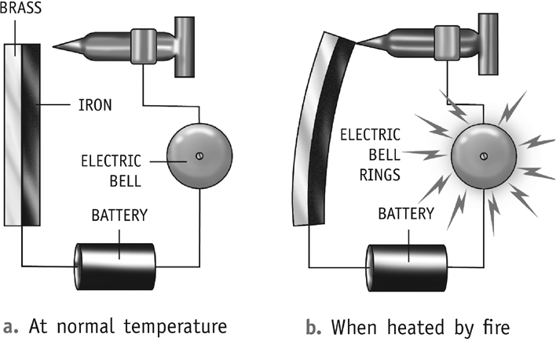
6.

D. 1. b 2. d 3. a 4. b
5. c 6. a 7. a 8. b
9. b 10. c 11. b 12. d
13. a 14. d 15. d

11. RESPIRATION
- 120 Oral Questions
  - Breathing is the word used for external respiration, that is, taking in oxygen and giving out carbon dioxide. But the process of respiration consists of breathing as well as cellular respiration, that is, using oxygen to break down food to release energy.
  - animals
  - through cell membrane or skin, for example, in Amoeba and earthworm; through air holes in cockroaches; through gills in fishes
- 124 Oral Questions
  - alveoli 2. oxyhaemoglobin
- oxidation – oxidation of sugar molecules to form carbon dioxide, water and give out energy
- anaerobic respiration
- combustion
P. 126 Exercises
A. 1. a 2. a 3. d 4. b
5. d 6. a 7. b 8. c
- 1. cellular respiration 2. epiglottis
3. diaphragm 4. breathing, external
5. stomata 6. diffusion
7. true 8. oxidized
- false
- Trachea, bronchi, lungs, blood vessels, blood
- haemoglobin
- 1. The reaction of any substance with oxygen is known as oxidation.
- We should not overwater potted plants as the water replaces the air in the soil and the roots cannot breathe.
- Stomata along with its nearby guard cells and other cells are called the stomatal apparatus.
- The main organs of the respiratory system in human beings are
  - nostrils
  - pharynx or throat cavity
  - trachea or wind pipe
  - bronchus
  - bronchioles in lungs
  - alveoli in lungs
  - diaphragm
- During cellular respiration, the sugar molecules in food are oxidized to form carbon dioxide and water, and energy is given out.
The reaction involved is as follows:
C6H12O6 + 6O2 6CO2 + 6H2O + energy
glucose oxygen carbon water
dioxide
- While doing exercise, a person needs extra energy. So, the breathing becomes faster, supplying more oxygen, thus releasing more energy.
- During anaerobic respiration in yeast, glucose is broken into alcohol and carbon dioxide releasing energy.
- The athlete can overcome the cramps by massaging the affected part or by taking a hot bath.
- 1. The two main processes of respiration are:
  - External respiration or breathing, that is, taking in air rich in oxygen (inhalation) and giving out air rich in carbon dioxide (exhalation).
  - Internal respiration or cellular respiration, that is, using oxygen to break down food to release energy. Internal respiration occurs in the body cells.
- a. Fishes use gills for exchange of gases. Gills are made up of a large numbers of filaments, richly supplied with thin blood veins called capillaries. As water enters
through the mouth it flows over the gills. The blood in the capillaries absorbs oxygen and gives out carbon dioxide through its walls.
b. Cockroaches have openings called spiracles on their bodies. Air enters through these openings and reaches all parts of the body through respiratory tubes called trachea and their branches called tracheoles.
Living Science Companion – 7
- The air around us is impure. Our lungs require air which is moist, warm and clean. As the air, we breathe in, passes through the nostrils,
it is moistened by the slimy mucous present in the nose. Mucous is secreted by the inner lining of the nose. The air becomes warm by the blood circulating in the nose. The mucous and the hair present inside our nose trap dirt, dust particles and disease-causing germs,
19

and prevent them from entering the respiratory system.
4.
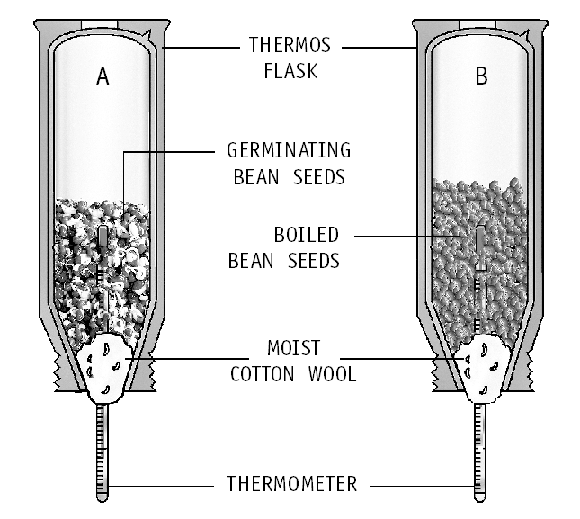
Two flasks were used in the experiment because two types of seeds were taken in them – flask A contains germinating bean seeds whereas flask B contains boiled bean seeds.
  - The air we breathe in eventually reaches the tiny air sacs called alveoli through the bronchus and its smaller branches, the bronchioles. The sacs are surrounded by blood vessels. The oxygen present in the air we breathe in, goes into the blood contained in blood vessels. The carbon dioxide present in the blood (as a waste product of respiration) passes out of the blood into the air sacs. Thus, exchange of gases takes place in the lungs.
  - In the lungs, each bronchus branches out into smaller tubes called bronchioles. At the end of these tubes are tiny air sacs called alveoli. Each lung contain about 300 million alveoli.
The air we breathe in eventually reaches these air sacs. The sacs are surrounded by blood vessels. The oxygen present in the air we breathe in, goes into the blood contained in blood vessels. The carbon dioxide present in the blood passes out of the blood into the air sacs. Thus, exchange of gases takes place in the lungs.
Living Science Companion – 7

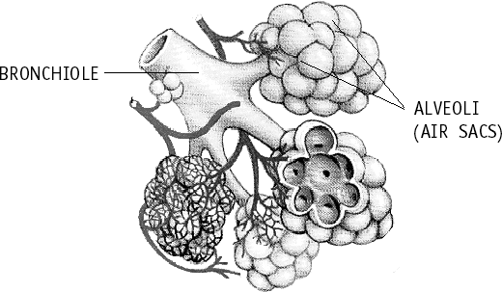
  - Similarity between cellular respiration and combustion is that the similar kind of chemical reaction occurs in both of them. Both the processes release energy.
Differences between combustion and cellular respiration are:
20
Combustion
- Combustion is a fast process and can occur anywhere.
- It occurs at high temperature.
- Energy is released in a single step in the form of heat and light.
Cellular respiration
- Cellular respiration is a slow process which occurs only in living cells.
- It occurs at body temperature.
- Energy is released in steps, and stored in chemical molecules called ATP.
  - Let us take two test tubes each of them half- filled with lime water. Using two-holed stoppers, glass tubes and clips, we set up the apparatus as shown. We use the rubber tube at the middle to breathe in and out through the mouth. As
we suck in air through the rubber tube, clip X is opened and clip Y is closed. The inhaled air
passes through lime water in test tube A. As we exhale through the rubber tube, clip Y is opened and clip X is closed. The exhaled air passes through the lime water in test tube B.
Lime water turns more milky in test tube B. This shows that exhaled air has more carbon dioxide.
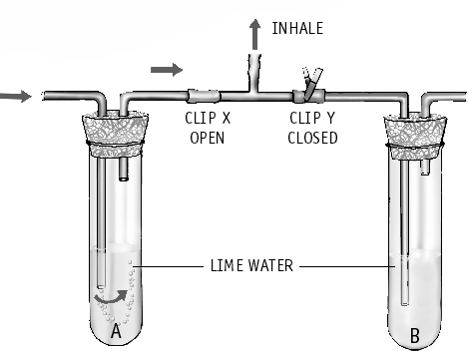

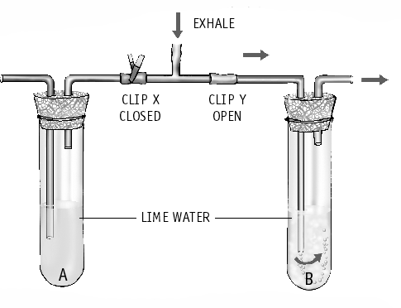
  - Breathing
    - It is a physical process of exchange of gases. No chemical reaction takes place.
    - It takes place outside the cells.
    - There is no release of energy.
Cellular respiration
- Chemical reaction of oxidation of food takes place.
- It takes place within the cells.
- There is release of energy.
  - Some organisms such as yeast and some

bacteria can live without oxygen. In their cells, glucose is broken into alcohol and cabon dioxide without using oxygen, to give energy. This process is called anaerobic respiration. The amount of energy given out in anaerobic respiration is much less than that in aerobic respiration.
Sometimes during strenuous activity such as long distance running, our body cannot get enough oxygen to produce the required
energy. To get the additional energy, anaerobic respiration occurs within our muscle cells.
  - During exercise, our body can not get enough oxygen to produce the required energy. To get the extra energy, anaerobic respiration takes place in our muscle cells. In this process, there is partial breakdown of glucose to produce lactic acid. The accumulation of lactic acid in the body causes muscular cramps. That is why we sometimes have cramps after heavy exercise.

HOTS Questions
- a. It is wise to sleep under a tree during the day as plants give out oxygen.
b. It is not wise to sleep under a tree at night. This is because plants give out carbon dioxide at night.
- Solubility of gases in water reduces with increase of temperature. Therefore warm water has less oxygen dissolved in it, and
the fish died because they did not get enough
oxygen.
- When we run, extra oxygen needed by the body cells to generate more energy is taken in by faster breathing. It is supplied to the body cells by increase in the rate of heartbeat, which increases the blood flow through the body.
- Plants do not need a respiratory system because plants show the simplest form of respiration, i.e. taking in oxygen and giving out carbon dioxide through stomatal openings in the leaves. This oxygen directly goes into the cells and no separate organs for breathing are necessary.
- If we hold our breath for some time, the body cells get starved of oxygen, and we have to then breathe heavily to supply extra oxygen.
- Yawns occur when the body needs additional oxygen or in other words, when there is an increased amount of carbon dioxide in the blood. When people are sleepy or drowsy,
their respiration slows down. This phenomenon leads to decrease in the level of oxygen and an increased carbon dioxide level in the blood.
- When we climb high mountains, we face
oxygen deficiency as the air is thinner higher
up. To supplement that scarcity, mountaineers climbing high mountains carry oxygen cylinders with them.

Be a Scientist
- Yes; the greater the maximum rate of oxygen consumption, the smaller is the time taken to run 10 km.
- Greater maximum rate of oxygen consumption means that the athlete’s body has the ability to generate more energy and hence the athlete can run faster.

12. TRANSPORTATION OF MATERIALS IN PLANTS AND ANIMALS
- 133 Oral Questions
  - No. Xylem, a set of pipe-like vessels, transports water and mineral salts whereas another set of tubes, phloem, transports food.
  - A semi-permeable membrane is a membrane that will allow certain molecules or ions to pass through it by diffusion.
Through such a membrane, passage of water takes place from the region of
more concentration to the region of less concentration.
  - Transpiration creates a suction pull which pulls water up the plant from the roots. Transpiration also cools the plants.
  - If water is lost more quickly through transpiration than it is absorbed by the root hairs, the leaves of a plant will wilt.
- 137 Oral Questions
  - No 2. RBC
- They fight against diseases by destroying
harmful bacteria and other foreign materials.
- In the lungs, carbon dioxide is removed from the blood and oxygen is absorbed.
- The weak sound is due to contraction of auricles and the stronger sound is due to the contraction of the ventricles.
- 138 Oral Questions
  - No, removal of waste like carbon dioxide is included under respiration. Again the removal of waste food, that is mainly undigested food, is included under digestion.
Living Science Companion – 7
  - nephrons
  - No, lower animals have no special excretory organs. In these animals, waste products are excreted by the process of diffusion through the body surface.
  - diabetes
- 140 Exercises
A. 1. a 2. d 3. c 4. d
5. a 6. b 7. b 8. c
21
9. a 10. c

  - 1. diffusion 2. ascent of sap
3. Phloem 4. blood
5. ventricles 6. true
7. haemoglobin 8. haemoglobin
- white blood cells or WBCs
- auricles, ventricles 11. veins
12. pulse 13. left
14. false 15. false
16. true 17. false
18. nephrons 19. diffusion
20. dialysis
  - 1. Plants have a transport system consisting of xylem and phloem. Xylem carries water and minerals from the roots to the stem and leaves whereas phloem carries food from leaves to all parts of the plant.
- The process of losing water in the form of water vapour from the leaves of a plant is known as transpiration.
- The process of transport of food from the leaves to other parts of the plant is known as translocation.
- Circulatory system is responsible for transportation of materials in humans. The circulatory system consists of the blood, the blood vessels and the heart.
- Valves are present inside heart in between two chambers which prevent the blood from going in the wrong direction in the heart.
- The stretching and relaxing of the arteries with each heartbeat is felt as a throbbing
called pulse. In this way heartbeat is related to pulse which is normally 60–80 times a minute throughout our life.
- After running, the body needs more oxygen for extra energy. To supplement the requirement, the rate of heartbeat increases after running.
- The process of removal of metabolic wastes from the body is known as excretion. This
is important because accumulation of these wastes beyond a level inside the body is harmful to the body.
- Urine examination is useful to the doctor because an examination of urine tells a lot whether various organs in the body are functioning normally. For example, the
Living Science Companion – 7
presence of sugar in the urine indicates that the person may be suffering from diabetes.
- Dialysis is a method of removing body wastes from the blood when the kidneys no longer function adequately.
  - 1. Root hairs are outgrowths from the layer of outer cells of the root. The root hairs increase the surface area of the root for absorption of water. This absorption of water takes place by a process called osmosis. The root hairs are in
22
close contact with water surrounded by the soil particles. Normally, water molecules are more crowded outside the root hairs than inside. So they move into the root hairs by osmosis. The water molecules then move through the root tissues to the xylem in the root.
- The process of losing excess water in the form of water vapour from a plant is known as transpiration. It creates a suction pull, which pulls water up the plants from the roots. As water is given out by transpiration, more water
is absorbed. This pull is strong enough to force water up high trees.
- In humans, food, oxygen, waste products, and so on have to be transported from one part of the body to another. Food and oxygen are transported to all the cells in the body for respiration and growth. Waste products are transported from the cells to the organs that excrete them.
- The circulatory system consists of the blood, the blood vessels, and the heart.
Function of the blood: a. It transports digested food from the small intestine to all parts of the body; b. It transports oxygen from the lungs
to the body cells and carbon dioxide from the cells to the lungs; c. It transports liquid waste from the body cells to the kidneys for removal from the body.
Function of blood vessels: They circulate blood through the body.
Function of heart: The heart pumps blood to all parts of the body.
- Arteries:
  - Arteries carry blood away from the heart.
  - They have thick elastic walls.
  - Pulse can be felt in arteries.
  - They generally carry oxygen-rich mixed pure blood except the pulmonary artery.
Veins:
- Veins carry blood back to the heart.
- They have thin walls.
- Pulse can not be felt in veins.
- They generally carry carbon dioxide-rich impure blood except the pulmonary vein.
Importance of capillaries:
Capillaries have very thin walls through which oxygen, digested food, carbon dioxide and other waste products are exchanged between the blood and the surrounding cells. Arteries branch into capillaries and again the capillaries join up to form the veins.
- If we observe a drop of blood under a microscope, we would see RBCs, WBCs and platelets. Functions of RBCs: They contain a red- coloured protein called haemoglobin, which

absorbs oxygen and transports it to the cells all over the body.
Functions of WBCs: They fight against diseases by destroying harmful bacteria and other foreign materials.
Functions of platelets: They help blood to clot whenever there is a wound on the body.
- The blood enters the right side of the heart and is pumped to the lungs where it gives up carbon dioxide and takes up oxygen. This oxygen-rich blood travels back to the left side of the heart. It is again sent to all other parts of the body and the process is repeated again and again.
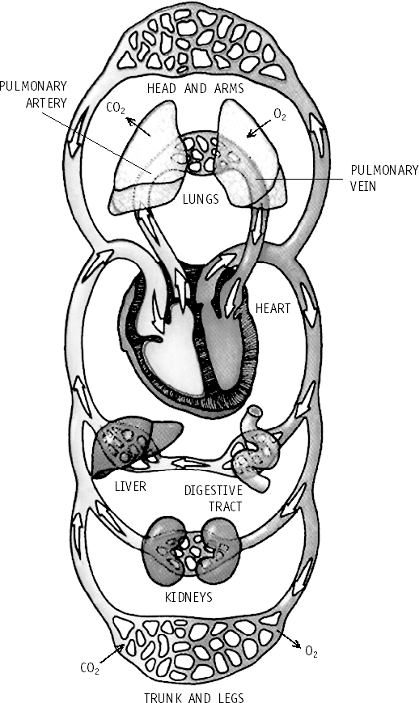

8.
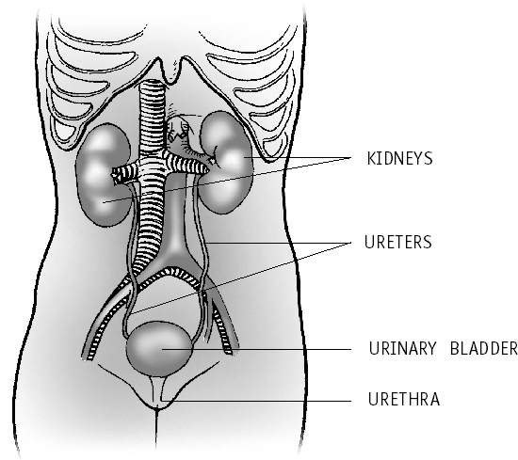
9. The blood gets filtered through the nephrons. They filter out excess water, salts and urea from the blood as it passes through them. The ‘clean’ blood leaves the kidneys and continues its circulation in the body. The wastes removed by the kidneys form a liquid called urine. It passes from the kidneys through two tubes called ureters into an elastic sac called the urinary bladder. The bladder stores the urine until it is excreted from the body through the urethra.

HOTS Questions
- The colour of blood is red due to presence of maximum number of red blood cells. The RBCs contain a red pigment called haemoglobin.
- Left side of heart has oxygen-rich blood whereas right side of heart has carbon dioxide- rich blood.
- Water enters the vegetables by the process of osmosis.
- Plants absorb so much water because the evaporation of excess water from the leaves produces a pulling force that causes the water to move upwards in the plant.
- Xylem transports water and minerals and this takes place from the roots to all parts of the plant, mostly leaves. So this transportation is in only one direction, upward. Food has to be reached all parts of plant including roots and the top most shoot. So the transport of food in phloem takes place in both directions.
- No, excretion is the removal of metabolic wastes from the body, that is, the wastes produces by the various chemical reactions that take place in the body. Undigested food are nothing but the undigested part of the food taken by the body.
- The auricles only receive the blood. But the ventricles pump the blood to various parts of the body. For this action, thick muscular walls are necessary in the ventricles.

Be a Scientist
- Loss of water from the body will cause a greater reduction in weight than will be caused by burning up of carbohydrates.
Living Science Companion – 7
- No; since there is an interfering factor (loss of water) in the experiment that affects the
measurement more than the factor she wants to measure.

13. REPRODUCTION IN PLANTS
- 149 Oral Questions
  - No, in plants, it can be 2 parents for some and only one parent for some.
  - a. binary fission b. budding c. budding
23
d. fragmentation e. vegetative reproduction

  - A seed is multicellular and contains the embryo and food for the young plant. A spore is usually unicellular and has no embryo and very little stored food.
  - vegetative reproduction, potato, strawberry
- 153 Oral Questions
  - No, because complete flowers like rose contain both female and male reproductive organs. So in these plants, only one flower is required for reproduction.
  - Pollination means the process of transference of pollen grains from the anthers to the stigma.
  - This helps in making wind pollination easier in
these flowers.
  - ovary, fruit
  - This is because the seeds need enough space, water, minerals and sunlight to develop into healthy plants. This will not happen if the seeds fall below the plant.
P. 154 Exercises
A. 1. b 2. d 3. a 4. b
5. b 6. d 7. c 8. c
9. a 10. d
- 1. asexual reproduction 2. spore
3. fragmentation 4. false
5. artificial propagation 6. fertilization
7. zygote 8. true
9. a. cotton b. pea 10. false
- 1. It is because of reproduction that life continues from generation to generation. Thus, it is important.
- flower, leaf
- Yeast reproduces by budding.
- Plants of lower order like mosses, ferns, moulds reproduce by spore formation.
- Asexual reproduction requires only one parent and the offspring is genetically identical to the parent. In sexual reproduction, two parents, one male and one female are required. The offspring has a mix of inherited genes.
- There are many forms of asexual reproduction in plants. They are:
  - Fragmentation, for example, in spirogyra
  - Budding, for example, in yeast
  - Spore formation, for example, in mosses
Living Science Companion – 7
- When new plants are produced from the vegetative parts of the mother plant, such as root, stem, or leaves, without the help of any reproductive organs, it is known as vegetative reproduction.
- The process of growing new plants by artificial methods is known as artificial propagation. Four methods of artificial propagation are:
  - grafting (ii) cutting
(iii) layering (iv) tissue-culture
- The process of fertilization consists of the
24
fusion of the male cell and the egg cell.
- A seed starts germinating only under favourable conditions that is when it gets moisture, warmth and oxygen.
- 1. Three different ways of vegetative reproduction are explained below.
  - Potato is an underground stem tuber. When it is cut into parts and planted in the soil, each part with an ‘eye’ develops into a new potato plant. At each eye is a bud which can develop into a new plant.
  - In some plants, such as strawberry and grasses, the main plant develops side shoots which have buds that grow into new plants.
  - The leaf of Bryophyllum has many buds on its margin. These buds give rise to new plants.
- Advantages of vegetative reproduction of plants are:
  - It allows to produce new plants quickly.
  - The plants produced by this method are exact copies of the parent plant.
  - They usually need less attention than plants grown from seeds in the early stages of growth.
  - New varieties of plants having required characteristics can be developed by this method.
- a. Cutting: In this method, a healthy young branch of a plant having leaf buds is cut off and planted in moist soil. The cutting develops roots and grows into a new plant, for example, rose, sugarcane.
- Layering: In this method, a young branch is bent towards the ground and covered with moist soil. After some time roots developed from the covered part. This is called a layer.
The branch can now be cut and made to grow into a new plant, for example, jasmine, rose.
- Grafting: In this method, a twig or bud of one plant (called the scion) is kept over the cut stem of another plant (called the stock) tying them up together. The tissues of stock and scion join together to form one plant, for example, mango.
- The process of transference of pollen grains from the anthers to the stigma is called pollination. After pollination, a thin tube called the pollen tube grows down from the pollen grain through the pistil. The pollen tube carries the male cell. It grows until it reaches the ovule and enters it. Fertilization takes place and the zygote is formed.

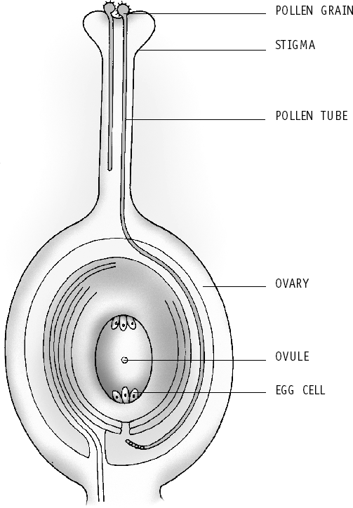
- A plant produces a large number of seeds. If all these fall below the plant and start growing, they will not get enough space, water, minerals and sunlight. So they will not develop into
healthy plants and many of them may even die. So dispersal of seeds is necessary by some natural agents by which the seeds of a plant get scattered over a large area.
Agent of dispersal seed dispersed wind cotton
water coconut
animal xanthium
explosion pea
- After the formation of the zygote in fertilization, the petals, sepals and stamens wither away and fall off. Often the style and the stigma also fall off. Only the ovary remains. The ovules in the ovary contain a supply of food. The zygote takes in this food and begins to grow by cell division. In some time, it becomes an embryo. Meanwhile, the walls of the ovules develop hard layers and form seeds. As the seeds form, the ovary begins to swell and in time, it becomes a fruit.
- In this method, a piece of tissue is cut off from the growing tip of a plant. The cells are
separated and kept in a nutrient medium under controlled conditions. The nutrient medium contains hormones that make the cells divide and form groups of cells. Roots also develop. These are then kept in a different nutrient medium containing hormones that enable shoots to develop.

HOTS Questions
- The statement is false because reproductive system is not needed for the organism to stay alive.
- Insect-pollinated flowers are expected to be more attractive to attract insects for pollination. Wind-pollinated flowers do not need to attract insects.
- If there is favourable wind, it can carry pollen grains from one insect-pollinated flower to the stigma of another and thus help in pollination.
- The number of cells gets multiplied by 2 every hour. Therefore:
  - After 5 hours: No. of cells = 2 × 2 × 2 × 2 × 2 = 32
  - After 10 hours: No. of cells = 2 × 2 × 2 × 2 × 2 × 2 × 2 × 2 × 2 × 2 = 1024
  - After 15 hours: No. of cells = 2 × 2 × 2 × 2
× 2 × 2 × 2 × 2 × 2 × 2 × 2 × 2 × 2 × 2 × 2 =
32768
(From the above it can be seen that the general formula is: No. of cells = 2n, where n is the time in which the number of cells doubles.)

14. MOTION AND TIME
- 161 Oral Questions
  - metre, kilogram, second, kelvin
  - Yes. We need to measure something that occurs or appears at regular intervals to measure time and this is very difficult to carry out.
  - increases
- 164 Oral Questions
  - s = d/t
  - uniform motion
  - a straight line
P. 165 Exercises
A. 1. c 2. b 3. c 4. a
5. b 6. c 7. b
- 1. physical quantities 2. false
3. true 4. oscillation
5. false 6. alance-wheel
7. stopwatch 8. speed
9. odometer 10. uniform motion
- 1. Standard units are used in measurements because they can be uniformly used by everyone.
- Discovery of the simple pendulum by Galileo Galilei made the accurate measurement of time possible.
Living Science Companion – 7
If a mass hung from a string is made to swing, it always completes one to-and-fro motion in exactly the same time.
- The time taken by a pendulum for one oscillation is known as its time period.
- The periodic change, rotation of earth on its axis, can be used to measure time.
- Modern electronic watches have the crystals of a substance called quartz. These crystals can vibrate very fast at a very precise rate. These
25

vibrations are used to measure time accurately.
- An object is said to be in uniform motion when it travels in a straight line and covers equal distances in equal intervals of time.
- 1. SI is the abbreviation of ‘Systeme International d’Unites’ in French. In this system the standard units are metre, kilogram, second and kelvin. Two other systems of units are FPS system and CGS system.
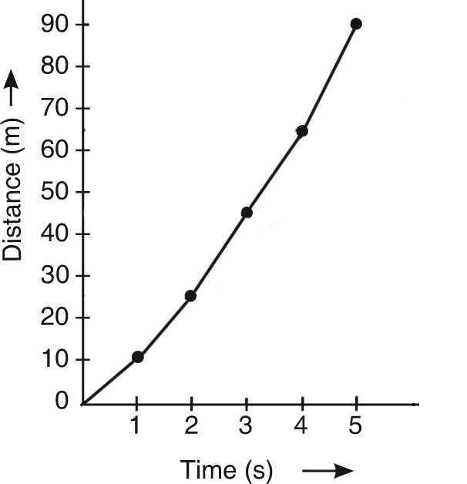
- distance (d) = 270 km
The speed of the car is s = d =
t
60 15
4
7.

= 15 m/s

Thus,
time (t) = 4 1
2
h = 9 h
2

speed (s) = d
t
= 270
9/2
= 270 30 × 2 = 60 km/h
9

Thus, the speed of the car is 60 km/h.
- a. distance (d) = 200 m time (t) = 10 s
The car does not have uniform motion.
8. An object is said to be in uniform motion when it travels in a straight line and covers equal

speed (s) =
d = 200
t 10
= 20 m/s
distances in equal intervals of time. The graph
of distance versus time for uniform motion is a straight line. A body is said to be in non-

b. d = 200 m = 200 1000
km = 2 km
10
uniform motion if the speed or direction of the body does not remain constant.

t = 10 s = 10
60 × 60
= 1 h
360
The graph of distance versus time for non-
uniform motion is not a straight line.

Thus, speed s =
d = 2
t 10
÷ 1
360
= 2
10
× 360 = 72 km/h

HOTS Questions
1. Making accurate measurements of length and mass is relatively simpler than making accurate

4. An aeroplane takes time to travel from New
Delhi to London = 7 h.
Plane travels at a speed = 950 km/h
Thus, distance (d) = s × t = 950 × 7 = 6650 km
5.
105 –
90 –
E
75 –
Distance (m)
D
60 –
C
45 –
30 – B
A
15 –
0
1 2 3 4 5 6 7
Time (s)
Distance-time graph for uniform motion
Living Science Companion – 7
6.
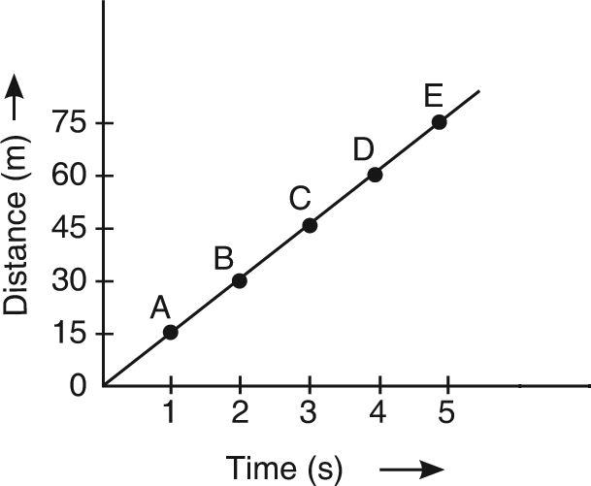
26
measurement of time. We need to measure something that occurs or appears at regular intervals to measure time and this is very difficult to carry out.
- By using a string shorter than 25 cm.
- No, it does not have uniform motion as its direction is changing continuously.
- Car A won the race as its speed is higher.
- Object A is at rest. Object B is travelling at
infinite speed.

Be a Scientist
- Graph B
- Graph A
- Graph C

15. WINDS, STORMS AND CYCLONES
- 174 Oral Questions
  - The atmospheric pressure at Mumbai; because air pressure decreases as we go higher
  - reduced pressure
  - upwards
- 178 Oral Questions
  - Towards the equator for both the cases; Air is cool in this place in comparison to that in the equator. So air from these places rush to take the place of warm air near equator as it rises up producing a low pressure.

  - Heating of the earth’s surface by the sun.
  - No. The strongest winds occur in the regions surrounding the eye. The cyclone consists of a low pressure region with a higher pressure all around. So the winds tend to blow towards the low pressure region.
  - over the sea
P. 179 Exercises
A. 1. a 2. d 3. d 4. c
5. c 6. c 7. b 8. d
- 1. decrease 2. decrease
3. less 4. smaller
5. true 6. Poles
7. sea/water 8. true
9. false 10. eye
- 1. Four natural hazards are earthquakes, floods,
droughts and cyclones.
- Air exerts pressure in all directions.
- This will reduce the pressure in the region.
- When air is heated, it expands. This causes it to become lighter than the surrounding cooler air, thus it rises up.
- Monsoon winds are caused by uneven heating of land and sea.
- Static electricity is produced due to the collisions between water droplets and ice crystals in atmosphere. This causes huge sparks between clouds or between a cloud and the ground in the form of lightning during a thunderstorm.
- The cyclone becomes weak once it hits land due to friction with land and shortage of moisture.
- A tornado is formed when a funnel-like column of cold air sinks down from a storm cloud. Warm air from the surface rises up, whirls around it and causes very high speed winds.
- 1. Rubber sucker when pressed against a flat smooth surface, forces air out between the smooth surface and the sucker. This reduces air pressure in the space between the sucker and the smooth surface. There is greater air pressure outside. Hence, this air pressure outside firmly presses the rubber sucker to the smooth surface.
- We have to tape cotton threads to two tennis balls and hang them 2–3 cm apart from each other at the same height. Now, we should blow air between them using a drinking straw. Harder we blow, the closer the balls come to each other. This happens because, when we blow between the two balls, the air pressure between them reduces.
- a. The wind blows towards the equator. This happens because the regions close to the equator get the maximum heat from
the sun. The air near the earth’s surface becomes warm and rises, producing a low pressure region. Cooler air from either side of the equator up to a latitude of about 30° rushes in to take its place.
- If the earth had stood still, these winds would have blown straight. But as the earth rotates, the winds in the Northern Hemisphere swerve to the right, and the winds in the Southern Hemisphere swerve to the left.
- The hazards associated with a cyclone are strong winds, heavy rains, tidal waves and floods. The high speed winds of tropical cyclones are accompanied by heavy rains and huge sea waves. Flooding is caused by the huge sea waves as they hit the coast, and the accompanying rain further worsens the
situation. Trees get uprooted, houses collapse, and telecommunication lines get disrupted, leading to heavy loss of life and property.
- At the centre of the cyclonic storm is a calm, cloudless area. This is called the eye. Its diameter may vary from 10 km to 30 km. There is no rain here, and the winds are fairly light.
- The Indian Meteorological Department studies the development and movement of cyclones. This is done with the help of INSAT satellite and chain of Cyclone Detection Radars (CDRs) installed along the coastal belt of India. These radars can locate and track an approaching cyclone within a range of 400 km.
- Precautions needed for the cyclone-prone regions are:
  - Listen weather bulletins regularly in radio and TV.
  - Store enough food articles in waterproof bags. Also store safe drinking water.
  - As soon as a warning is sounded, secure home well or move to the safer places.
  - Do not venture into the sea.
8.
Living Science Companion – 7

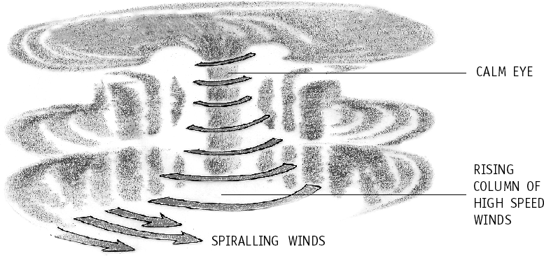

HOTS Questions
- Holes are necessary in hoardings to reduce the air pressure on them when the wind blows, as much of the air passes through the holes.
27
- No. We can not expect a cyclone to be formed

in the desert of Rajasthan as it usually forms over the sea.
- In winter the sea near the equator is warmer than the land. As the air above the sea rises, the air above the cooler land blows to take its place.
- If the earth rotated from east to west, instead of west to east, the winds in the northern hemisphere would swerve to the left instead of right, and the winds in the southern hemisphere would swerve to the right instead of left.
- The pressure would be low at B and C. However at A, directly in the path of the wind, the pressure would be high.

16. LIGHT
  - 187 Oral Questions
    - No 2. virtual image 3. all but E
4. 90° – the angle between the mirror and the
incident ray
- 191 Oral Questions
  - outwards
  - the rays meet (converge) at a point called the
Principal Focus (F) after reflection.
  - they diverge after reflection
  - No, the image is real for all other positions except when the object is between F and P in case of concave mirror.
  - concave mirror
  - Convex because it forms smaller images and hence can be used to view a much larger area.
- 194 Oral Questions
  - yes
  - they will diverge
  - they converge at a single point called the Principal Focus
  - This point lies at the centre of the lens and is called the optical centre of the lens.
  - convex
  - No, there are seven colours but they appear as one, that is, white as our eyes can not distinguish them separately.
P. 196 Exercises
A. 1. d 2. d 3. c 4. b
Living Science Companion – 7
5. b 6. b 7. d 8. c
9. a 10. c
- 1. false 2. false 3. behind
4. focus 5. concave 6. true
7. concave 8. converges 9. a thick lens
10. at 2F 11. false 12. prism
- 1. The angle formed by the ray of light or incident ray and the normal drawn at the point of incidence to the mirror surface is called the angle of incidence of that ray of light.
- The angle of incidence is equal to the angle of
28
reflection.
- The image which can be formed on a screen is called a real image.
- In the image formed by a plane mirror, there is an interchange of left and right. This is called lateral inversion.
- Because a convex mirror forms smaller images of objects, it can be used to view a much larger area than would be possible with a plane mirror.
- A convex lens bends all parallel rays passing through it inwards to meet or converge at a point called the focus. Thus, it is said to have a real focus. A concave lens makes spread all parallel rays away or diverge and it appears as if they were coming from a point called the focus. Thus, it is said to have a virtual focus.
- The pattern formed by the seven colours of ordinary white light is called a spectrum.
- The convex lens forms a virtual image when the object is between O and F. Bigger than the object.
- 1.

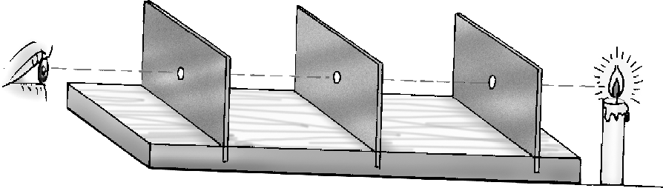
- The characteristics of the image formed by a plane mirror are:
  - It is virtual (ii) It is erect
- It is of the same size as the object
- It appears to be as much behind the mirror as the object is in front of it
- It is laterally inverted
- Three uses of concave mirrors are:
  - Used in torches and car headlights to reflect
the light to form a poweful beam of light
  - Used in the astronomical telescope to form an image of the star or planet
  - Used by dentists to magnify the image of teeth
- A real image can be taken on screen whereas a virtual image cannot be taken on screen. In case of convex lens real images are always formed (except in magnifying glass) whereas in case of concave lens virtual images are always formed.
- a. Position of the object between O and F: Position of the image – behind the mirror Nature of the image – virtual, magnified
and erect
  - Position of the object between F and C: Position of the image – beyond C
Nature of the image – real, magnified and
inverted
  - Position of the object beyond C:
Position of the image – between F and C Nature of the image – real, diminished and
inverted

- a. Position of the object between O and F:
Position of the image – on same side as
object Nature of the image – virtual, erect,
magnified
- Position of the object between F and 2F: Position of the image – beyond 2F Nature of the image – real, inverted,
magnified
- Position of the object beyond 2F: Position of the image – between F & 2F Nature of the image – real, inverted,
diminished
7.

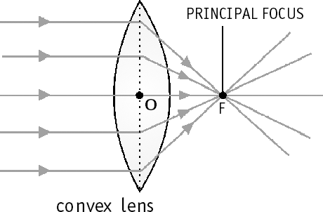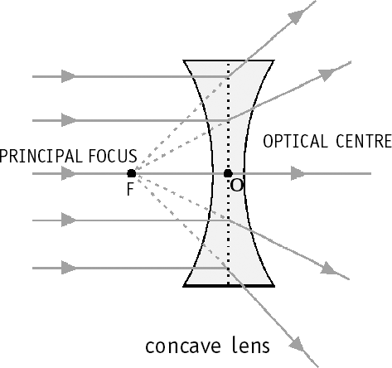
Principal focus: The point ‘F’ in the figure for convex lens is actually the real image of the sun formed on a screen. This point is called the principal focus of the lens. In the case of a concave lens, a virtual image will be formed at the point F which is the pricipal focus of the lens.
Focal length: The distance between the optical centre O and the focus F of a lens is called the focal length (OF).
- Newton showed that a prism can produce a spectrum. He allowed a thin beam of light to fall on a prism in a dark room. After passing through the prism, the beam splits into its different colours. A spectrum was seen on a screen kept behind the prism.

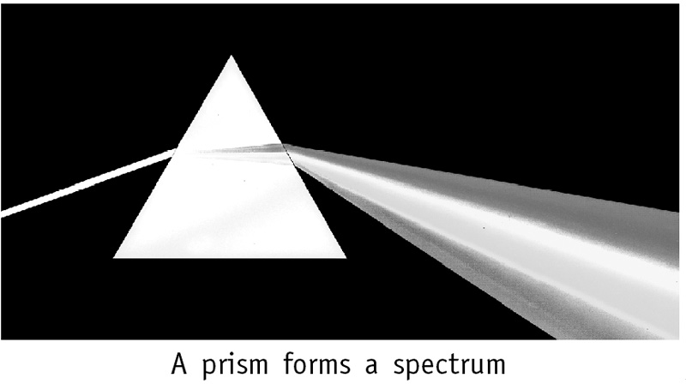

HOTS Questions
  - No difference. The size of the image of any object formed on a plane mirror does not depend on the size of the mirror.
  - Four identical mirror image letters H, I, O, X
  - Rear view mirrors are convex to have a useful field of view. They form a smaller image of the object behind them. Since smaller objects appear farther away, the objects seen in the mirror look further away than they really are. If the driver does not realise this, he might turn or change lanes thinking that the car behind is further away than it actually is. This can result in an accident. The warning is there to remind the driver of this potential problem.
  - A concave mirror converges parallel rays of light after reflection so that they actually meet at the focus and form a real image. Therefore the focus is real. A convex mirror diverges parallel rays of light after reflection so that they appear to come from the focus. Therefore the focus is virtual.
By the same logic a convex lens has a real focus (as it converges parallel rays), and a concave lens a virtual focus (as it diverges parallel rays).
  - Glass lens will have a greater focal length because it bends light less than diamond.
  - In plane mirror, all normals at the surface are parallel to each other.
  - Infinite number of images, as the image formed by one mirror becomes the object for the other mirror and so on.

Be a Scientist
Ray no 5

17. ELECTRIC CURRENT AND ITS EFFECTS
- 204 Oral Questions
  - No, it can be placed anywhere in the circuit. The function of the switch is to either open or close the circuit, and it has no relation with the cell.
  - air
  - low resistance, high resistance
  - positive, so current always flows from positive
Living Science Companion – 7
terminal to negative terminal
- 208 Oral Questions
  - It must have a low melting point.
  - only when a current is flowing in the wire
  - to increase the strength of the magnet
P. 209 Exercises
A. 1. a 2. a 3. d 4. c 5. d 6. d
- 1. air 2. true
3. true 4. diagram
5. B A 6. false
7. heating effect 8. false
29
- electromagnet 10. false

- 1. The arrangement where an electric current flows in a conductor when it is connected to a source of electric current is known as an electric circuit.
  - Electric current always flows from high potential to low potential. This creates the flow of electric current in an electric circuit.
  - Every conductor does not heat up when an electric current is passed through it. The amount of heat depends on the resistance offered by the conductor and also the length and thickness of the conductor. Nichrome and tungsten are conductors normally used in heating appliances.
  - The fuse wire will melt.
  - A miniature circuit breaker is a switch that automatically stops the current in a circuit if the current in it exceeds the specified maximum limit.
  - Symbols used in the circuit: a battery of four cells :
+
–

a switch :
a lamp :
- 1.

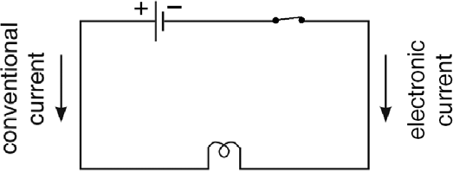
- The magnetic strength of a solenoid can be increased by:
  - Increasing the number of turns in the solenoid
  - Increasing the current in the solenoid
  - Winding the solenoid around a magnetic material
- An electromagnet is a coil of insulated wire wound around a piece of magnetic substance, such as soft iron, which acts as a magnet only as long as the current is flowing in the wire. Three uses of electromagnets are:
  - Used in a number of electrical appliances, such as electric bells and electric buzzers
  - Used in electric motors, which find wide application in fans, washing machines, air conditioners and so on
Living Science Companion – 7
  - Used in factories and cranes for lifting heavy iron pieces
- An electric bell consists of an electromagnet, an armature, a contact adjusting screw, a gong and a hammer. The armature consists of a soft iron rod mounted on a spring. One end of the iron rod presses against the top of the contact adjusting screw. When the switch is pressed on, current flows in the electromagnet. It then attracts the iron rod towards itself, causing the
30
hammer to strike the gong. At the same time, the armature loses contact with the screw and the current is switched off. This causes the electromagnet to lose its magnetism and the armature springs back to its original position to close the circuit once again. Current flows
again and the cycle repeats itself till the current is switched off.

HOTS Questions
  - An electric cell gives a very low voltage as compared to the mains. Therefore, there is no danger of high current flow in a circuit
containing electric cells. Hence fuse wires and circuit breakers, which are safety devices to prevent accidents, are not required.
  - Copper wire cannot be used in electric bulbs as it will offer very little resistance to the flow of current and will therefore not get heated up.
  - The fuse wire will melt when the AC is switched on, as the normal current that the AC will draw (10 A) is greater than the rating of the fuse
wire (5 A). Mohit should use a fuse wire of
specification greater than 10 A, e.g. 15 A.
  - 100 A is much higher than the total maximum current of 20 A drawn when all appliances are switched on. Hence the fuse wire specification is not right. It should be a little higher than
20 A, e.g. 25 A.
  - Heating up of fans, air conditioners, refrigerators, computers etc., when current is passed through them are examples of wastage of energy.
  - If a current is passed through the coil, the freely suspended coil will deflect towards north–south direction because the current carrying coil acts as a magnet.

Be a Scientist
    - The switch will cause a short-circuit. All current will flow through the switch and none through the lamp. The lamp will not glow.
    - The two cells will tend to drive the current in opposite directions, which will cancel each other so no current will flow. The lamp will not glow.
    - The two cells will drive the current in the same direction. The lamp will glow.

18. WATER—A NATURAL RESOURCE
- 217 Oral Questions
  - a renewable resource
  - sea water, frozen water, groundwater
  - Yes. I do agree.
  - No, water evaporates at all temperatures.
- 220 Oral Questions
  - The depth of the water surface in the well from the surface of the earth.

  - Yes. Because forest and vegetation slows down the flow of rainwater on land and increases the absorption of water by the soil which in turn recharges the groundwater.
  - conservation
  - rainwater harvesting
P. 222 Exercises
A. 1. b 2. c 3. a 4. b
5. a 6. c 7. a 8. d
- 1. both 2. false 3. false
4. true 5. absorption 6. false
7. conservation 8. water table 9. true
10. true
- 1. There is shortage of water even though three- fourths of the earth is covered with water because it is not evenly spread throughout the earth, and also because most of it is not in a usable form.
- The three states of water are ice, water and steam. The state of water can be changed by heating or cooling.
- The rainwater falling on land may drain into rivers and streams or seep through the soil and gather underground as groundwater, or fall on high mountains and get frozen.
- The level at which all the spaces between the soil particles and the gaps between rocks are filled with water is known as the water table.
- The groundwater may run along the surface of the non-porous rocks and come out of the surface at some places to form a natural spring.
- Drip irrigation is a method of irrigation where water is supplied to the roots of plants drop by drop instead of filling the entire field with water.
- Trees and vegetation slows down the flow of rainwater on land and increases the absorption of water by the soil. Also, planting trees helps in soil conservation which in turn helps in groundwater conservation.
- 1. (i) Renewable resources are those that will never run out or are replaced through natural processes. They are of two types:
  - inexhaustible, like sunlight, air, water
  - exhaustible, like soil, forests, groundwater
(ii) Non-renewable resources are those that once used up cannot be replaced in a reasonable period of time. They are of two types: a. can be recycled like minerals
b. cannot be recycled like topsoil, fossil fuels
- a. Groundwater is a renewable resource However, today we are using it, at a faster rate than the rate at which it is renewed which leads to the depletion of the water table.
- Forests are destroyed increasingly by cutting or burning of trees to obtain wood, land,
etc. due to which they are disappearing at a faster rate and getting exhausted.
- It is seen that the water table in our cities is constantly going down and there is shortage of groundwater. The reasons are as follow:
Rising population leads to an increase in the water consumption. There is also a need for moe number of houses, offices, shops and roads, and this means more construction work which uses a lot of water, mostly groundwater.
Also as the build-up areas increases and open areas reduces, there is a reduction in the amount of water seeping into the ground.
For these reasons, the water table in the cities constantly decreases.
- The water in seas, rivers, lakes and streams evaporates due to the heat of the sun. The water vapour rises up. The air higher up is cooler. This cools the water vapour and it condenses to form tiny drops of water. These drops of water unite together to form clouds. As the clouds get cooled further, more water drops unite together and become bigger. When they become too heavy, they fall on the earth as rain.
- Conservation of resources means avoiding their wasteful use. This definition does not cover the other aspects of conservation, i.e. it means not only wasting the resources, but also maintaining their quality. The natural resources today are getting used up and depleted much faster which leads to an imbalance in nature.
So the main purpose of conservation is to use resources wisely and carefully so that a balance in nature is maintained.
- Four methods of conserving water are:
  - Rainwater harvesting: It is done by allowing rainwater, falling on roofs of buildings, to flow into a deep trench in the ground. It, thus, replenishes groundwater.
  - Using better methods of irrigation, such as drip irrigation in which water is supplied to the root of plants drop by drop.
  - Using less water and avoiding wastage at home, for example, turning off the tap while brushing teeth, etc.
  - Better management of water by the civic authorities, e.g. preventing leakage from pipes.
Living Science Companion – 7
- Rainwater harvesting is being encouraged by the government these days as an important
method of conserving groundwater. It is a method of storing rainwater for future use. In houses, it
is done by allowing rainwater, falling on roofs
of buildings, to flow into a deep trench in the ground. It, thus, replenishes groundwater, instead of flowing off into drains that empty into rivers.

HOTS Questions
- Renewable resource (but exhaustible if we use it faster than it is replenished) as 10 years is a
31

resonable period of time for the resource to be replaced.
- We feel greater need for conservation today because with increase in population, and with advancement in science and technology, we are using up much more resources than our ancestors did.
- Wells go dry because of decrease of the water table to below the depth to which the wells were dug. Either the well should be dug to a greater depth, or we should recharge groundwater by using rainwater harvesting to increase the water table.
- The density of air is less high up in the atmosphere. It can therefore not retain heat and is cooler.
- When the humidity is high and the temperature is low, condensation takes place because of which fog forms.

19. OUR FORESTS
- 227 Oral Questions
  - canopy
  - small trees, shrubs and tall grasses, herbs
  - Rainwater falls on the leaves of trees and plants and then drips slowly onto the forest floor. Thus water does not fall directly on the forest floor and hence does not collect and stagnate there. So even after heavy rains, forest generally do not get flooded.
  - Plants and trees in the forest release water into the air through transpiration. This increases the amount of water vapour or moisture in the air and this increased amount of moisture also cools the air.
- 231 Oral Questions
  - Help in pollination, help in dispersal of seeds, animal excreta and their dead bodies provide nutrients
  - No, consumers are those that depend directly or indirectly on plants for food. So all animals including humans are consumers.
  - The balance of nutrients in the soil must be maintained as the total amount of these
nutrients does not change. This happens when the decomposers break down the dead bodies of plants and animals into the nutrients they are made up of and mix them with the soil.
Living Science Companion – 7
  - food web
  - In planned harvesting, the uncut trees prevent soil erosion. Again, the fruits of these trees produce seeds so that new trees can grow and thus the forest cover is almost maintained.
P. 232 Exercises
A. 1. b 2. c 3. c 4. c 5. d
6. d 7. d 8. b 9. b 10. c
32
- 1. canopy 2. neem
3. erosion 4. oxygen
5. water vapour 6. secondary consumers
7. sun 8. mushroom
9. web
- 1. The thick covering of leaves like a roof known as canopy hardly allows any sunlight to come in. Thus, it is quite dark inside a thick forest.
- When a city is made in place of forest, the water table goes down because people need water for drinking, washing, cooking, cleaning and so on. More construction of houses is needed which uses a lot of water mostly groundwater. Again increase in build-
up areas and reduction in open areas causes a decrease in the seepage of water into the ground lowering the water table.
- Five products that we get from forests are timber, wood pulp (for making paper), turpentine, latex (for manufacture of rubber) and resin.
- Jackal, vulture. They consume dead animals and dispose them off thus keeping our environment clean.
- Suppose there is a food chain:
plant rat snake.
But there are several animals other than the snake that eat rat, for example, cat or owl. So another food chain can be:
plant rat cat.
Now, as we see, these two food chains are interconnected:
cat
plant rat
snake
- Forest fires are controlled by spraying fire extinguishing solutions from aircrafts or by changing the direction of wind by using strong blowers.
- Afforestation is the practice of renewing a forest by planting seedlings or small trees.
- 1. Two ways in which plants are useful to animals are:
  - Plants release oxygen during photosynthesis.
  - Plants provide food to all animals including human beings.
Two ways in which animals are useful to plants are:
- Some animals such as butterfly, honeybee, humming bird, bat and moth help flowers in pollination.
- Animal excreta and their dead bodies add nutrients to the soil. They act as manure and provide minerals for plant growth.
- A food chain tells us who eats what in the environment. It shows how energy in the form of food is passed from one organism to other. For example, green plants deer lion. This means that green plants are eaten by deer

and a deer is eaten by a lion.
- There are several food chains in nature that are connected to each other. A food web is a web of a number of interconnected food chains. For example,
small birds
plants or grass grasshopper frog snake rat snake
There are animals other than the grasshopper that eat plants. There are also animals other than the frog that eat grasshoppers.
- Nature maintains the population of each species of animals in sufficient numbers to maintain a balance. That is why we say that to kill and to be killed, to grow and to die and get decomposed is the law of nature. It is due to these activities that the balance in nature is maintained.
- The roots of plants bind the soil particles together and prevent soil erosion, and thus maintain
the fertility of the soil. Soil erosion is also prevented because raindrops do not fall directly on the forest floor with full force. In this way by conserving forests, we also conserve soil.
- An efficient way to get wood from forests for our requirements is to cut only some of the trees in an area. The uncut trees prevent erosion. Fruits of these trees produce seeds so that new trees can grow. This way the forest cover is maintained. In this way planned harvesting also helps in conservation.
- Forests prevent soil erosion. Again forests provide the best habitat for wildlife as food and shelter are available for a large number of wild animals in the forests. So conservation of forests helps in wildlife conservation as well as soil conservation.
- Five ways in which forests are useful to us are:
  - Prevent floods and maintain the water table
  - Prevent soil erosion
  - Supply oxygen and Absorb carbon dioxide
  - Cool the air and increase rainfall
  - Yield valuable products such as timber, wood pulp, latex, spices and medicinal plants.
- Yes, large scale cutting down of forests have an effect on rainfall in the area. Plants in the forest absorb water from the soil and release it into the air through transpiration. This increases the amount of water vapour in the
air and helps in cloud formation. This ultimately causes an increase in rainfall.

HOTS Questions
- If all forests on the earth disappear, most plants and animals would disappear, the carbon dioxide levels in the air would increase, the rain patterns would get adversely affected,
and soil erosion would increase. Therefore,
survival of life would become more difficult.
- Banning the cutting down of trees completely is not practical as we need wood for several
purposes. Planned harvesting of trees – so that we get our requirements without reducing the forest cover – is a practical method.
- A forest has no waste. It is true because every bit of it is used in one or other way. Even the dead leaves decay and make compost.
- If the number of carnivores became more than the number of herbivores, the carnivores will first eat up all the herbivores. Once the herbivores finish, all food chains will get disrupted as transfer of food from plants to animals would not take place. The carnivores will therefore also perish. Thus all animal life would end.

Be a Scientist
- If the predator population exceeds the prey population, there will not be enough food for the predators to survive, and they will die. A balance will be reached where the predator population is smaller than the prey population so that enough food is available to them.
- The prey population increases as there is more food available to them due to increase in plant population during the rainy season.
- As the prey population increases, more food becomes available to the predators and their population also increases.
- As the predator population increases, they kill more prey for their food requirement, and the prey population thus starts declining (Point B).
- When the prey population decreases (Point C), there is less food available to the predators and their population also starts decreasing.
- If the prey dies in large numbers, there will be less food available to the predators and their population will decrease sharply. The shape of the graph will therefore change.

20. WASTEWATER MANAGEMENT
- 238 Oral Questions
Living Science Companion – 7
  - In our homes, industries, offices, hospitals, and other places. It is also generated as rainwater runs down the land through roofs, ground and agricultural fields.
  - There can be blockages in open drains. So sewage may stagnate and even overflow. This results in breeding of mosquitoes, flies and other germs.
  - No, there can be leaks at the damaged joints in the pipes. This could be a major risk for public health particularly where drinking water pipe and sewage pipe pass close to each other.
33

- 240 Oral Questions
  - The aim of sewage treatment is to remove the solid material from the sewage and also to make its liquid part less harmful for humans and other animals.
  - a. Cooking oil can block pipes when it hardens.
  - Sanitary napkins can clog drains and prevent free flow of oxygen that interferes with the decomposition process.
  - Paints can kill microbes that clean the water.
  - Faeces, food waste, soap. They grow in air pumped in the tank and consume these contaminants to remove them.
P. 241 Exercises
A. 1. b 2. c 3. d 4. a
- 1. mosquitoes 2. false
3. oxygen 4. true
- 1. Wastewater from houses, industries, hospitals, etc., and rainwater that runs over land containing waste matter such as excreta is called sewage.
- It is necessary to treat sewage before disposing it off in a water body. Without being treated, it can result in a major health hazard for humans and animals.
- yellow fever, malaria, dengue, cholera
- During floods, sanitation system can overflow and this may contaminate drinking water supply and cause sewage to back flow. For this reason, cholera outbreak is common after floods.
- In a city, the amount of storm water collected can be very large. This can cause overflowing of and bursting of sewage pipes, if there are
no separate pipes for sewage and storm water. Also the large quantity of storm water can not be properly treated in a treatment plant.
- Sewage treatment involves physical, chemical and biological processes.
- Contamination of drinking water can happen in covered drains also. A common reason is damaged, leaky joints in water pipes in areas where the water pipes and sewage lines are close to each other.
- 1. When we use water at home to wash clothes and utensils, bathe and flush toilets, it becomes dirty. This dirty water is called wastewater.
Living Science Companion – 7
It contains urine, faeces, detergent and dirt released after washing clothes and utensils, and food wastes. Harmful microorganisms that can cause diseases such as jaundice, cholera and typhoid are present in it.
Wastewater is also generated in industries, hospitals, hotels, offices and at other places. Industrial wastewater contains poisonous chemicals. Wastewater from hospitals may contain several types of disease-causing germs, and dangerous radioactive materials.
34
Rainwater that has run down the land also forms wastewater. It may pick up various contaminants including soil particles, heavy metals, organic compounds, animal waste, and oil and grease. It may also pick up human faeces. It also picks up fertilizers and pesticides.
- Due to improper drainage, sewage may collect in pools and stagnate. These are perfect places for flies and mosquitoes to breed. This may spread diseases such as yellow fever, malaria and dengue. Different types of germs such as those of cholera can also grow and multiply in stagnant wastewater. Decay of organic waste present in wastewater leads to unpleasent smell.
- If a city does not have proper storm water drainage system, this water starts overflowing on the streets and may even enter houses. This is dangerous for public health and property. Sanitation system can overflow during floods. There is also the risk of floodwater contaminating drinking water supplies, bursting pipelines and cause sewers to back flow or even break.
- The main steps used in sewage treatment are:
Screening
  - The wastewater is first passed through screens of vertical bars, which remove large soild materials such as plastic bags, sticks, etc.
  - The water is then passed through settling tanks known as grit chambers. Its speed is reduced so that solids such as sand,
silt and gravel settle down and are removed.
Primary treatment
  - After this, the wastewater passes into a sedimentation tank called a clarifier, in which organic materials settle down and are
removed with a scraper. Floating materials like oil and grease are removed with the help of
a skimmer. The water that emerges from the
settling tank is called clarified water.
Secondary treatment
  - Next air is passed through the clarified water in an aeration tank. This allows aerobic bacteria to grow and consume organic contaminants. The water is removed from the top.
Disinfection
  - The water is then disinfected by adding chlorine to it, or by exposing it to ultraviolet rays. This kills disease-causing germs. The water can now be released into a water body such as a river or lake and used for agricultural or industrial purposes.
- The sludge is used to obtain methane, carbon dioxide and humus like material by a process

called digestion. It consists of decomposing the sludge with the help of anaerobic bacteria. Dried sludge can be used as a fertilizer. The methane formed can be used as a fuel.
- Do not dispose off cooking oils and fats in the kitchen sink. They can block pipes when they harden. Throw them in dustbins.
Do not dispose off used tea leaves, solid food remains, sanitary napkins, etc. in the kitchen sink or in the toilet. They clog drains and prevent free flow of oxygen that interferes with the decomposition process. Throw them in dustbins.
- One such method involves making a septic tank. The sewage is allowed to flow into a tank in which anaerobic bacteria decompose the waste. Another method allows the excreta to flow into a biogas plant through covered drains. The biogas produced can be used as a fuel.
A new method recently tested in India is to use
- The angle of incidence is same as the angle of
reflection.
- A miniature circuit breaker is a switch that automatically stops the current in a circuit if the current in it exceeds the specified maximum limit.
- Water exists in nature in solid form in glaciers; in liquid form in ponds, lakes, rivers, oceans and underground; and in the form of water vapour in air.
- Rainwater falls on the leaves of plants and trees in the forest and then drips slowly onto the forest floor which helps this water to easily seep into the soil and recharge the water table.
- 1. Cellular respiration occurs in the cells. During cellular respiration, the sugar molecules in food are oxidized to form carbon dioxide and water and energy is given out.
The reaction is:

red worms to treat human excreta and convert
it into vermicompost. This method is simple,
C6H12O6
+ 6O2
6CO2
+ 6H2O + energy

hygienic and uses less water.
35

HOTS Questions
  - Storm water disposal pipes should be bigger because the amount of storm water can be very large.
  - Because the quantum of plastic disposed off in the form of plastic bags is many times more than the quantum disposed off as other plastic products such as buckets or TV cabinets. This is because plastic bags normally get disposed off after a single use, whereas one bucket may be disposed off after several years of use.

ANNUAL TEST PAPER
for Chapters 11–20
- 1. Chlorophyll 2. temperature
  - Acids 4. Chemical
5. respiration 6. asexual reproduction
7. oscillatory motion 8. real
- inexhaustible renewable resource
- septic
- 1. Salivary glands, stomach, liver, pancreas
- In insects, exchange of gases for respiration occurs through openings called spiracles on their bodies.
- Transpiration creates a suction pull which pulls water up the stem from the roots.
- Nephrons are the tiny filtering units of the
kidney.
5. d = s × t, or d = 60 × ¾ = 45 So the distance AB is 45 km.
6. High speed winds often lift off roofs of houses with tin or thatch roofs due to reduction in air pressure above the roofs.
- The cyclone consists of a low pressure region with higher pressure all around. The winds tend to blow towards the low pressure region and circulate violently around the centre with great speed. At the centre of the storm is a calm, cloudless area called the eye. There is no rain here, and the winds are fairly light.
- When the object is far away from the convex lens, the image will be real and inverted. Then, as the object is brought close to the lens, the image becomes bigger and moves further away from the lens. When the object is very close to the lens, an erect, magnified, virtual image can be seen on the same side as the object.
- A body is said to be in uniform motion if it travels in a straight line and covers
equal distances in equal intervals of time. In other words, the direction of motion and the speed of a body in uniform motion do not change.
The graph of distance versus time for uniform motion is always a straight line.
Living Science Companion – 7
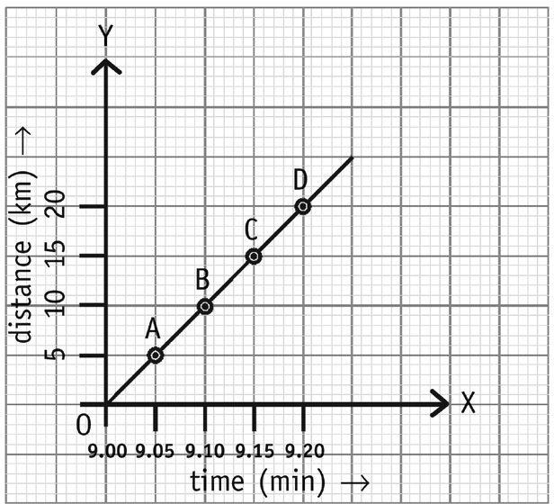

You can see that the car travels every 5 km in every 5 minutes for the entire journey. That is, travelling in a straight line, it covers equal distances in equal intervals of time. If you
calculate its speed for the entire journey, or for any interval of time during the journey, it will be the same.
Speed for the entire journey:
It covers 20 km in 20 minutes, or in 1/3 hour. Speed = d/t = 20 km/(1/3) h = 60 km/h Speed for the time interval 9 to 9.05:
It covers 5 km in 5 minutes or in 1/12 hour Speed = d/t = 5 km/(1/12) h = 60 km/h
- Rainwater harvesting is a method of storing rainwater for future use. It is done by allowing rainwater falling on roofs of buildings to flow into a deep trench in the ground. It replenishes groundwater instead of allowing the water to flow off into drains and water bodies.
6.

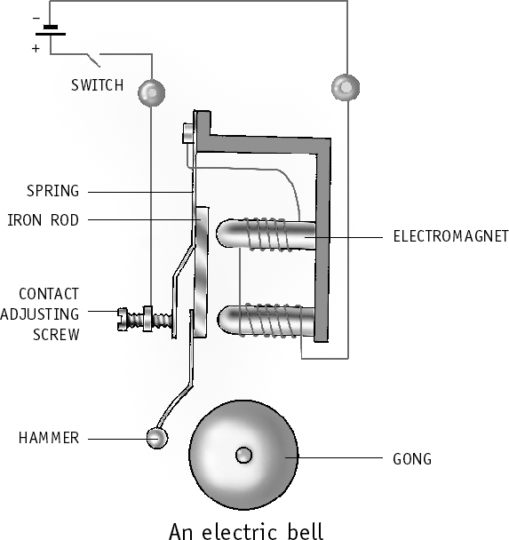
D. 1. b 2. c 3. c 4. d
5. a 6. a 7. c 8. c
9. b 10. c 11. b 12. b
13. c 14. a 15. b

H H H H H
Living Science Companion – 7

36

